2025 Bachelor’s Graduation Thesis

Development of a CAM System for Incremental Forming of CFRTP from 3D CAD Data

Precision Engineering Research Group
Green Engineering and Applied Sciences Course
Faculty of Science and Technology
Sophia University

A2177802
Karter Wong

Guidance Professor Hidetake Tanaka
Submitted on 17 July 2022

Table of Contents
Chapter 1: Introduction 4
1.1 Background information: Incremental Forming 4
Development History of Incremental Forming 4
Types of Incremental Forming 4
Current and Potential Applications for Incremental Forming 6
1.2 NC Machine Tools 8
Overview 8
NC program, G-Code, and Functions 8
3D CAD 9
CAM Systems 9
Python 10
Toolpath 10
1.3 CFRP (Carbon Fiber Reinforced Plastic) 11
Overview 11
Classification and Characteristics of CFRP 11
1.4 Previous Research A 11
Overview 11
CAM System and Design of the Test Shape 11
Experimental Equipment 12
Results 12
Previous Research Conclusions 13
1.5 Current Research Objectives 14
Chapter 2: Toolpath Generation 14
2.1 Program Overview 14
2.2 Libraries and Variables 15
Libraries 15
Variables 15
2.3 Modules 16
Loading STL File and Extracting Point Cloud 16
Cluster Prevention 17
Overlap Prevention 17
Smoothing Hull Points 18
Applying Reverse Offset 19
2.4 Toolpath Generation Process 20
Main Toolpath Generation Loop 20
2.6 G-Code Generation and Export 21
2.7 NC Viewer Confirmation 22
Chapter 3: Incremental Forming Experiment and Evaluation 22
3.1 Introduction 22
Experimental Equipment 22
Machining Center 23
Discontinuous CFRTP 24
Oil Bath 24
Type of Oil 24
Forming tool 25
Aluminum and Carbon Fiber molds 25
Jig Dimensions 26
Test shape 28
3.3 Experimental Setup and Procedure 29
3.4 Experimental Results 29
CAM System Comparison 29
Incremental Forming Experiments 30
Nylon Sheet Tests 31
CFRTP Tests 33
3.5 Evaluation 34
Toolpath Precision and Error-Free Generation 35
Speed of Toolpath Generation 35
Streamlining Design-to-Manufacturing 35
Experimental Outcomes 36
Chapter 4: Conclusion and Future Improvements 36
Conclusion 36
Future Improvements 37
Appendix 38
Chapter 5: References 59

Chapter 1: Introduction

1.1 Background information: Incremental Forming
The increasing demand for lightweight, durable, and reusable materials in modern products has highlighted Carbon Fiber Reinforced Plastics (CFRP) due to its high strength-to-weight ratio and excellent mechanical properties [10]. Traditional molding techniques, while efficient for high-volume production, are too costly for low-volume and complex-designed products [2]. The low volume production, in addition to the mold costs, increases manufacturing and consumer costs, limiting accessibility. Dieless forming methods, such as 3D printing and incremental forming, offer a potential solution to produce low-volume products by eliminating the need for molds while allowing for the manufacturing of complex shapes [2]. The exceptional properties of CFRP make it challenging to manufacture products using innovative techniques, such as incremental forming, to address the challenges of manufacturing low-volume, high-mix production [2].

Development History of Incremental Forming
Incremental forming, pioneered in Japan during the 1990s by researchers, is a dieless manufacturing technique designed for low-volume, complex components. Unlike traditional manufacturing techniques, incremental forming deforms materials through small tool movements, allowing the production of intricate details, prototyping, and production of custom parts [2]. The key characteristic of incremental forming is its ability to manufacture products without molds, which is cost-effective for low-demand components.

Types of Incremental Forming
There are many types of incremental forming; however, most are categorized into three main categories: Single Point Incremental Forming (SPIF), Two Point Incremental Forming (TPIF), and Double-Sided Incremental Forming (DSIF). For this research paper, single-point incremental forming was employed; therefore, two-point and double-sided incremental forming will not be discussed in the following sections as they are not relevant to the research paper.

Single Point Incremental Forming (SPIF)
Single-point incremental forming is the most straightforward and economical variant of incremental forming, where a tool deforms a sheet without the need for a mold. A backing plate or Jig is often used to support the workpiece or sheet of material. SPIF's ability to manufacture products without molds allows it to be used for rapid prototyping and low-volume production, as SPIF can be used on conventional CNC machines. However, SPIF may suffer from reduced accuracy due to springback and longer forming times for larger workpieces. Applications include prototyping and small-batch production, with studies highlighting its increased formability but lower final accuracy [2].
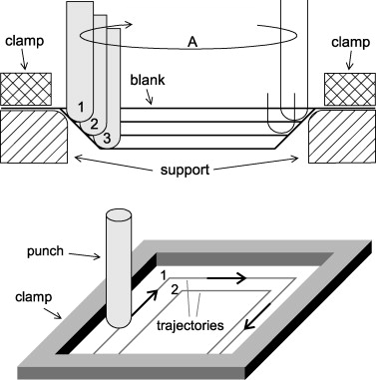
Figure 1: Principle of Single Point Incremental forming [Iseki et al., 1989].

Two-Point Incremental Forming (TPIF)
Two-Point Incremental Forming (TPIF) enhances the SPIF process by adding a supporting die that is partially or fully beneath the material. The forming tool presses the sheet against the die to increase stability and control during deformation. This setup improves dimensional accuracy and surface quality compared to SPIF, as the die helps to reduce springback and ensures the sheet is formed more accurately. TPIF is helpful in situations where producing parts that stick to precise parameters or detailed features, making it suitable for automotive panels or aerospace components, where precision is critical. The trade-off, however, is the need to design and manufacture the die, which increases tooling costs and setup time. This trade-off makes TPIF less ideal for one-off prototypes but more practical for small-to-medium production runs where the improved part quality can justify the investment in a die.

Double-Sided Incremental Forming (DSIF)
Double-sided incremental Forming (DSIF) uses two forming tools—one on each side of the sheet metal that work together to deform the sheet simultaneously, applying forces from both directions. This dual-tool approach enhances formability, allowing for more complex shapes than using SPIF. DSIF can shorten the forming process and minimize defects like uneven surfaces or tearing in materials that have low ductility. DSIF has the potential for manufacturing using high-strength materials or parts that have intricate details. However, because DSIF uses two forming tools that work simultaneously, it makes the manufacturing process more complex, often requiring advanced equipment such as specialized CNC machines. This increased level of complexity raises both the cost and the technical skill required to manufacture, which makes DSIF better suited for advanced manufacturing scenarios rather than simple prototyping.

Current and Potential Applications for Incremental Forming
Incremental forming's ability to efficiently and cost-effectively manufacture complex shapes makes it ideal for low-volume but complex product manufacturing, prototyping, and custom component production [2]. By eliminating the need for dedicated molds, incremental forming reduces setup costs and lead times, enabling rapid production and customization across various industries. Incremental forming's ability to produce complex shapes with high forming limits enables incremental forming as a solution for applications requiring lightweight, durable components, especially when using advanced materials like Carbon Fiber Reinforced Thermoplastics (CFRTP) [2].
The broad applications of incremental forming highlight its potential to change the way we manufacture products on a large scale, particularly for components made from materials that are harder to manufacture with traditional methods. By enabling the cost-effective production of complex, lightweight parts, incremental forming can meet the sustainability goals of various industries, which align with the global trends toward reduced emissions and increased resource efficiency [15].

Automotive Industry
In the automotive sector, incremental forming has seen an increase in the use of incremental forming technology for the low-volume production of complex, lightweight components [6]. For example, the Toyota Motor Corporation utilizes SPIF to fabricate the front bumper of the Lexus LC Edge, achieving precise shaping without the use of molds. Using SPIF reduces production costs by approximately 30% compared to traditional molding for low-volume items [6]. The bumper is constructed from discontinuous CFRTP, which has a high press formability, to achieve a smooth surface and dimensional accuracy of ±0.1 mm [6]. Similarly, Ford utilizes incremental forming for custom interior panels in the Mustang Mach-E electric vehicle, enabling the rapid prototyping of lightweight dashboard components with complex curvatures and reducing the component's weight by 15% compared to aluminum alternatives [6]. Nissan applies incremental forming for structural components in the Leaf electric vehicle, such as battery enclosure supports, which benefit from CFRTP's vibration absorption and corrosion resistance, enhancing vehicle range by 5% through weight reduction [6]. These applications of incremental forming showcase its ability to meet stringent automotive requirements for weight, strength, and cost efficiency.

Figure 2: Incremental Forming Application in Lexus LC Edge Front Bumper [Toyota Motor Corporation, 2020].

Aerospace Industry
Similar to the automotive industry, incremental forming is used for prototyping and fabricating lightweight, high-strength components that can also reduce the vibration in aircraft and complex structural parts. Incremental forming's ability to machine materials such as titanium and aluminum alloys, which are prevalent in the aerospace industry, makes it suitable for producing parts with materials that are already being used and materials that meet the requirements. Studies suggest that incremental forming could be used to manufacture parts on aircrews, such as parts for the wing or fuselage sections, contributing to weight reduction and improved fuel efficiency of the aircraft design [15]. These applications highlight the potential for SPIF to be used in the aerospace industry.

Medical Applications
Incremental forming is utilized in the medical field for the manufacturing of customized implants, including cranial and other types of implants, where precision is life or death. Incremental forming allows for the creation of complex, patient-specific geometries using materials such as titanium. A study by Duflou et al., done in 2013, demonstrated the application of SPIF in producing accurate titanium craniofacial implants that met medical standards and could be used [2]. Other research has explored SPIF for thin-shell clavicle implants, highlighting the versatility of SPIF in medical device manufacturing [4]. The capabilities of incremental forming could improve patient outcomes in reconstructive and orthopedic surgeries.

1.2 NC Machine Tools

Overview
Numerical Control or NC machines execute automated operations using a programmed set of numerical commands, controlling tool position, speed, and operations with high precision [9]. Unlike manual manufacturing processes, NC automation speeds up manufacturing, enhances productivity, and lowers labor costs. However, to use NC machines, the Toolpath for the machining process needs to be programmed line by line. Computer Numerical Control, or CNC, is an advanced form of numerical control that utilizes computer systems to manufacture products accurately, making it widely used in commercial manufacturing [9].

NC program, G-Code, and Functions
An NC program automates CNC machine operations through blocks of code, such as:
G01 X8 Y10 Z9;
Each block comprises a preparatory function section, the G01 section for linear interpolation, and a coordinate section, X8 Y10 Z9, for tool position. Codes that start with the letter “G” serve as preparatory functions, M-codes handle miscellaneous functions (e.g., spindle start/stop), F-codes set feed rates, and S-codes control spindle speed [9]. Table 1 lists the functions used in this research.
Table 1: G-Code Functions for Incremental Forming
G-Code | Positioning | G00
G-Code | Linear Interpolation | G01
G-Code | mm input | G21
G-Code | Absolute coordinate command | G90
G-Code | Relative coordinate command | G91
G-Code | Work coordinate system settings. | G92
M Code | Spindle section | M03
M Code | Program end | M30
F Code | Feed Speed (mm/min) | F1000
S Code | Rotation Speed (RPM) | S500

3D CAD
Computer-Aided Design (CAD) software enables precise digital design of components [7]. Unlike 2D CAD, 3D CAD, such as Creo Parametric 4.0 used in this study, supports complex geometries and prototyping, reducing production errors by enabling the accurate generation of STL files for toolpath creation [7]. All test pieces and molds in this research were designed using 3D CAD to ensure precision in incremental forming.
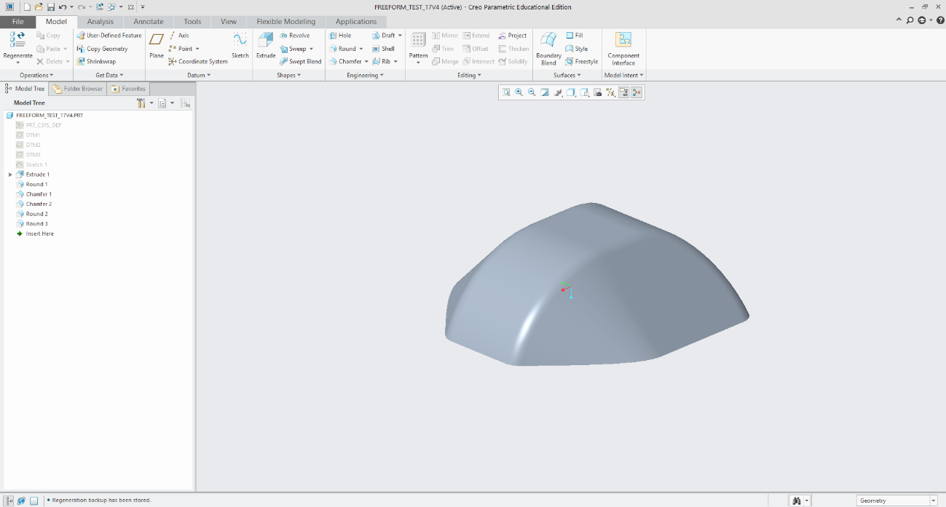
Figure 3: 3D CAD Model of Test Piece Designed in Creo Parametric [Wong, 2025].

CAM Systems
Computer-aided manufacturing, or CAM systems, utilize software and computer-controlled machinery to automate the manufacturing process. CAM systems are used to generate machining programs for CNC machines, automating the creation of toolpaths and reducing errors [7]. By simulating the generated toolpaths before forming, issues with the Toolpath can be identified and fixed before manufacturing, significantly lowering production time and costs [7]. In this study, the CAM system processes STL files from Creo Parametric to produce the NC program for incremental forming.

G90 ; (Absolute positioning)
G21 ; (Set units to millimeters)
G92 X0.0 Y0.0 Z0 ; (Set workpiece origin)
F1000 ; (Set feed rate)
G01 X0.0 Y0.0 Z20 ; (Move to safe height)

Figure 4: Sample NC program for Incremental Forming [Wong, 2025].

Python
Python is an open-source programming language that is known for its simplicity and libraries that enable programmers to develop complex programs [3]. Libraries such as ' NumPy ' and 'Pandas' can efficiently process large amounts of data, making them an ideal choice for this research. In this study, Python was selected for its simple-to-understand jargon and its ability to process CAD data and generate optimized G-code toolpaths for incremental forming.

Toolpath
A tool path is the path along which a machining tool moves. A tool path is created using the 3D coordinates of an STL file from CAD software to collect all the points, forming a point cloud from the triangles of the STL file. From this, the points are sorted, duplicate points are deleted, a set of coordinates is generated, and then the necessary pieces are added to convert the coordinates into the NC program. The NC program can instruct the tool on the machining path. The Toolpath was viewed using an NC viewer web browser to identify potential issues before manufacturing.
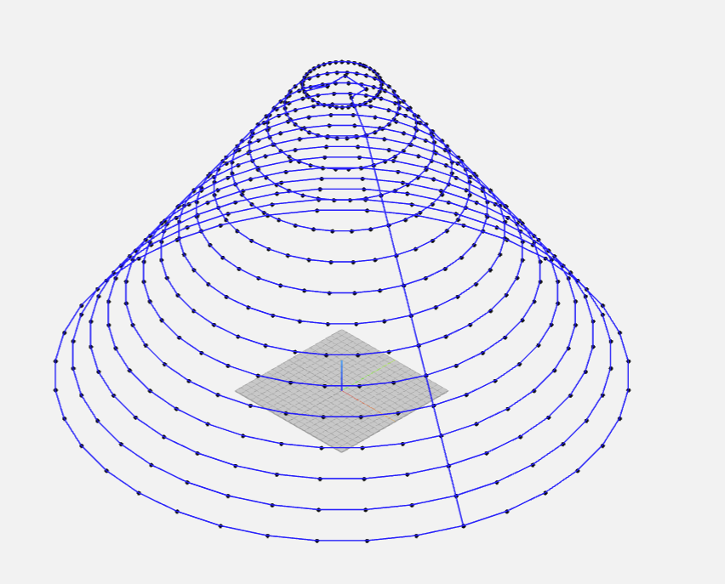
Figure 5: Toolpath Visualization for Truncated Cone [Wong, 2025].

1.3 CFRP (Carbon Fiber Reinforced Plastic)

Overview
Carbon Fiber Reinforced Plastics (CFRP) combine carbon fibers with a polymer matrix to achieve superior mechanical properties, including a specific strength up to 10 times that of iron and a specific gravity of 1.8 g/cm³, which is significantly lower than that of aluminum 2.7 g/cm³ [10]. CFRP's characteristics make it ideal for use in various industries that stress the importance of lightweight and durable materials, such as aerospace, automotive, and sports industries.

Classification and Characteristics of CFRP
CFRP is categorized by matrix type and fiber orientation, influencing its mechanical properties and applications [10]. The four main properties are Thermosetting (CFRTS), Thermoplastic (CFRTP), continuous fiber, and discontinuous fiber CFRP. CFRTS is characterized by a high specific strength and heat resistance. However, it requires long molding times and is non-recyclable [10]. CFRTS is used in the aerospace industry and sports equipment. CFRTP offers lower specific strength and heat resistance but enables shorter molding times, lower costs, and partial recyclability [10]. Continuous Fiber CFRTP features a layered structure with aligned fibers, providing high specific strength but limited formability [10]. Discontinuous Fiber CFRTP features a random fiber
orientation, providing isotropic strength and high press formability, which makes it ideal for complex shapes despite its lower overall strength [10].

1.4 Previous Research A

Overview
In this previous research, the researcher developed a Python-based CAM system for static incremental forming of discontinuous fiber CFRTP, utilizing an oil bath for material heating to enable dieless forming. The system generates NC program toolpaths from CAD models, addressing the high costs and inflexibility of traditional molding for low-volume, thin-shell components [5]. The CAM system for the previous research is outlined in Appendix Code A3.

CAM System and Design of the Test Shape
The CAM system achieves three goals: reading an STL file from Creo Parametric 4.0, extracting the 3D point clouds of the target shapes, and creating a tool path in G-code [5]. The code utilizes Python libraries to generate a point cloud from the STL file. It converts the clouds into layers by Z-height and connects the points in each layer by the minimum Euclidean distance. Finally, it takes the coordinates and adds the proper syntax for use by the CNC machines. The shape created in Creo was a truncated cone with varying dimensions. The radius of the shape ranges from 20 mm to 40 mm, and similarly, the wall angle is 30°, 40°, and 50°. The pitch or resolution of the STL is 1. The dimensions were selected to match the working area and limitations of the experimental setup. The shape was chosen because it is suitable for proof of concept, especially for plastic deformation layering [5].

Experimental Equipment
The experimental setup for this research is summarized in Table 2, with most equipment reused from the previous research for consistency and reproducibility.
Table 2: Experimental Equipment Specifications
Equipment | Description | Specification
CFRTP Sheet | PA6 matrix, 20 wt% carbon fiber | 110 mm × 110 mm × 1 mm
Oil Bath | T-22H (Thomas Scientific) | Up to 200°C, ±0.2°C precision, jet circulation
Silicone Oil | KF968 (Shin-Etsu) | Non-volatile, stable to 250°C, fire-resistant
CNC Machine | Sodick MC430L | X 420 mm, Y 350 mm, Z 200 mm, feed up to 36 m/min
Tool (Mandrel) | SUS304 | 5 mm diameter, 2.5 mm radius tip, 60 mm length
Jig | Custom design | Submerged in an oil bath, secure clamping, detachable

Results
The experiments identified key parameters that influence the success of incremental forming, including material temperature, tool rotation, wall angle, and radius [5]. These will briefly be covered in the following subsections.
Temperature Effects
The optimal forming occurred at 150–200°C (453–473 K), achieving smooth surfaces and minimal defects. Below 150°C (433 K), there was insufficient softening, leading to cracks, with a minimum forming temperature of 50°C (323 K) [5].
Tool Rotation
A spindle speed of 1000 rpm enhanced forming depth (up to 14.9 mm) and surface smoothness (Ra < 2 µm), reducing uneven wall thickness compared to non-rotating conditions [5].
Wall Angle
Wall angles of 30° and 40° yielded smooth forming with minimal springback of less than 5%. Angles near 40° exhibited minor deformations, while angles greater than or equal to 50° were at risk of cracking due to excessive stress [5].
Radius Variations
The test shapes with a smaller radius of around 20 mm achieved deeper forming of 14.9 mm but increased wall stress up to 300 MPa, while larger radii of 40 mm produced shallower depths of about 8 mm with uniform wall strength [5].
Table 3: Forming Criteria Summary
Condition | Depth (mm) | Temperature (°C) | Radius (mm) | Wall Angle (°) | Spindle Speed (rpm)
Maximum | 14.9 | 200 | 20 | 40 | 1000
Minimum | 3.6 | 160 | 40 | 50 | 0

Previous Research Conclusions
The previous research [6] developed a Python-based CAM system that effectively generates toolpaths from STL data for use in static incremental forming of discontinuous CFRTP. By leveraging Python libraries such as PyVista, Pandas, and NumPy, the CAM system extracted a 3D point cloud, sorted them by Z-height, and connected points using a nearest-neighbor algorithm while also showcasing the effects of different experimental conditions using incremental forming [5]. The use of Python to create a toolpath enables the CAM system to be compatible with any CAD software that can produce STL files, thereby streamlining the process from design to manufacturing. However, the CAM system itself has several limitations, preventing it from handling complex geometries and is susceptible to toolpath errors, such as creating a "messy" toolpath that moves the tool to unnecessary points.
During the incremental forming experiments, it was found that wall angles of 50° or greater had a higher chance of breaking the test piece [5]. The Author of previous research A highlighted some challenges for future experiments, namely the issue of springback shape distortion and the need for advanced evaluation methods, suggesting that including scribed circle tests and 3D scanning with Einscan-SE might help with analyzing the formed shape [5].

1.5 Current Research Objectives
This study aims to enhance the CAM system by building upon previous research, as outlined in the Appendix. The primary areas of focus for the CAM system are its ability to produce precise, error-free toolpaths for the static incremental forming of discontinuous CFRTP, the speed at which the program can output the Toolpath, and streamlining the process from design to manufacturing. To evaluate the CAM system’s ability to generate an error-free toolpath, the Toolpath's performance will first be presented in an NC viewer to confirm a clean toolpath and then tested using a Sodick MC430L CNC machining center in controlled heating conditions, with an oil bath at 120°C. The research will utilize the CAM system from previous research as a baseline for the new complex test shape, which will be presented later in the paper.

Chapter 2: Toolpath Generation

2.1 Program Overview
This chapter describes the changes and overall flow of the updated CAM system, based on previous research, to enable the system to support complex geometries. The updated CAM system’s overall workflow is similar to that of the previous CAM system; it takes STL data from CAD software, generates a toolpath, and converts it to G-code for CNC machining [5]. The updated workflow introduces a step where all the logic for making the Toolpath is done. The entire CAM system is outlined in Section A1 of the Appendix.
Figure 6: CAM System Workflow for Toolpath Generation [Wong, 2025].

2.2 Libraries and Variables

Libraries
Python libraries are collections of pre-written code that provide reusable functions and tools to simplify programming tasks. Libraries help optimize code that is used for computational problem-solving, simulations, and optimization [3]. Python offers an extensive library and the ability for third-party programmers to create libraries that can be made publicly available. The updated CAM system uses several libraries to optimize the Toolpath's generation, with required installations listed in the Appendix, code A2
The updated CAM system uses several libraries to optimize the Toolpath's generation.
- Pandas: This library primarily manipulates and stores data. Pandas uses the `DataFrame` structure to store a large amount of data that can be edited. In this research, point cloud data extracted from STL files is stored to manage large datasets [3] efficiently.
- NumPy: Numpy can do high-performance numerical operations, including array manipulations and linear algebra functions. NumPy's efficiency is crucial for handling the computational demands of toolpath generation, as it can calculate the distances between points [3].
- SciPy (ConvexHull): The `ConvexHull` module from SciPy computes the convex hull of 2D point sets. It identifies the outermost points of each layer to define the toolpath boundary [3]. The function of the library ensures that only the external contour of the shape is machined, reducing unnecessary tool movements.
- STL (numpy-stl): The `mesh` module from the `numpy-stl` library reads STL files, extracting the points' coordinates to form the point cloud used for toolpath generation [7]. STL files are standard in CAD systems for representing 3D geometries as triangular meshes.

Variables
The previous CAM system also had variables. However, their primary function was to store values for the toolpath generation. In the updated CAM system, several variables were added to allow the operator to adjust the values according to the shape being created easily. The following variables are important to change depending on the test shape.
- TOOL_DIAMETER: The tool diameter variable, as the name suggests, is the diameter of the forming tool. This parameter is used to calculate the offsets, ensuring the tool's geometry is accounted for during forming [5]. The use of diameter is for simplicity, as the program can halve the value for the radius.
- Z_SPRINGBACK_OFFSET: When conducting incremental forming without a mold, the material often rebounds slightly; this phenomenon is called springback [12]. This variable typically has a negative value, which shifts the Z-coordinates down, thereby ensuring that the shape is machined correctly.
- LAYER_THICKNESS: During the incremental forming process, it is important to maintain uniform layer thicknesses. Uniform layer distances will improve the formability of the formed shape; this variable defines the vertical distance between layers, controlling the resolution of the Toolpath along the Z-axis. Uniform layer spacing ensures consistent forming depth [5].
- MIN_DISTANCE: The minimum distance variable is used to prevent clusters of points from forming along the Toolpath. This variable ensures that the Toolpath is smooth while also preventing any unnecessary tool movements, reducing the time required to process the points [5].
- Z_OFFSET: This variable offsets the Z-coordinate of the entire Toolpath to align with the CNC machine's workspace, ensuring the tool operates within the safe working area [9].
- SAFE_Z_RELATIVE: This variable specifies the height to which the tool will retract after forming, preventing the tool from doing any damage to the machined shape and preventing the tool from breaking.

2.3 Modules
The majority of the changes made to the CAM system are located in the setup of variables, libraries, and the logic section of the code. The changes can be seen when comparing Appendix A1 and Appendix A3. In that section, the code can be broken down into several subsections or modules. The modules are designed in this way so that the points are in a refined state before being run through the main toolpath loop or setting up the logic to be used in the main toolpath loop. The sections of code that are being referenced can be found in the Appendix, in order from section code A4 to A9.

Loading STL File and Extracting Point Cloud
This module reads the STL file and converts its vertices into a structured point cloud, assigning them Cartesian coordinates (X, Y, and Z) for toolpath generation as illustrated in Appendix, Figure A2 for the truncated cone. The module then edits the point cloud to ensure that the layers grouped by the Z coordinate are equidistant from each other. The code accomplishes this by rounding the Z coordinate value to the nearest multiple of the layer thickness that was previously set. The module then removes duplicate points and incomplete coordinates to enhance computational efficiency and toolpath accuracy, which is key when processing complex geometries [5]. Then, the points are saved into a data frame for later use. The code A4 section of the Appendix has the portion of the code that outlines the loading of the STL file.

Cluster Prevention
This module sets up some logic to be used in the main toolpath generation loop. The module reduces the point density in the point cloud to remove clusters of points, which could lead to inefficient toolpaths or machining errors. The module accomplishes this by loading the output from the previous module, calculating the distance from the initial point in the list of points, and removing any point that exceeds the value of the min_distance variable that the operator can set. The filtered points are returned as a NumPy array, preserving only points that are spaced apart. By enforcing the minimum distance, this function optimizes the Toolpath by reducing the number of points processed by the CAM system and the machining center.
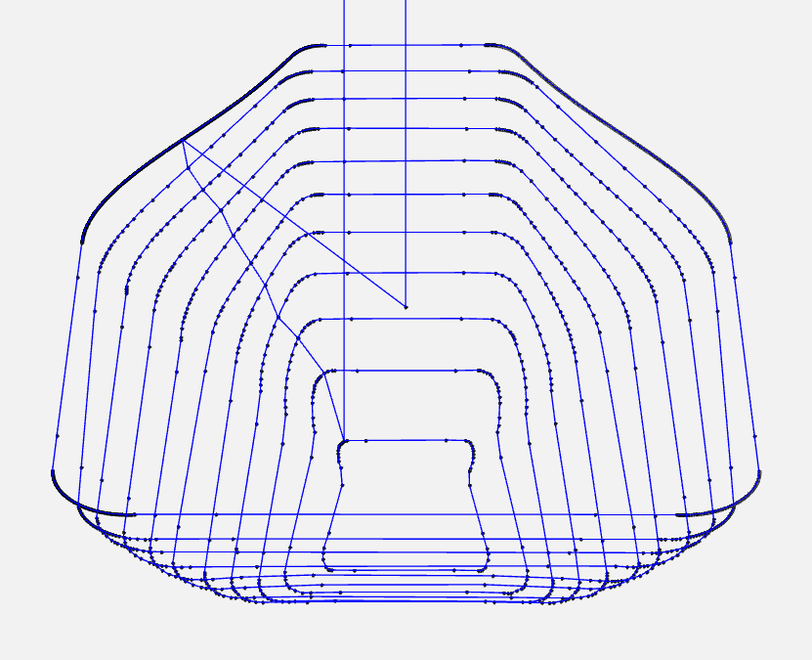
Figure 7: Toolpath Without the Clustering Function

Overlap Prevention
This module sorts points of each layer to create a non-overlapping, clockwise toolpath, minimizing travel distance and preventing toolpath intersections. The module calculates the mean of the points and determines the centroid of the layer. The layer's centroid then serves as a reference for calculating the angles of each point. The module sorts the points by these angles, reversing the order of points if there are any intersections between the lines it temporarily creates to prevent doubling back.
The overlap prevention module is inspired by the Traveling Salesperson Problem (TSP), which calculates an efficient and non-overlapping path from a given set of points. By preventing doubling back, it reduces machining time and mitigates risks of toolpath errors [5].
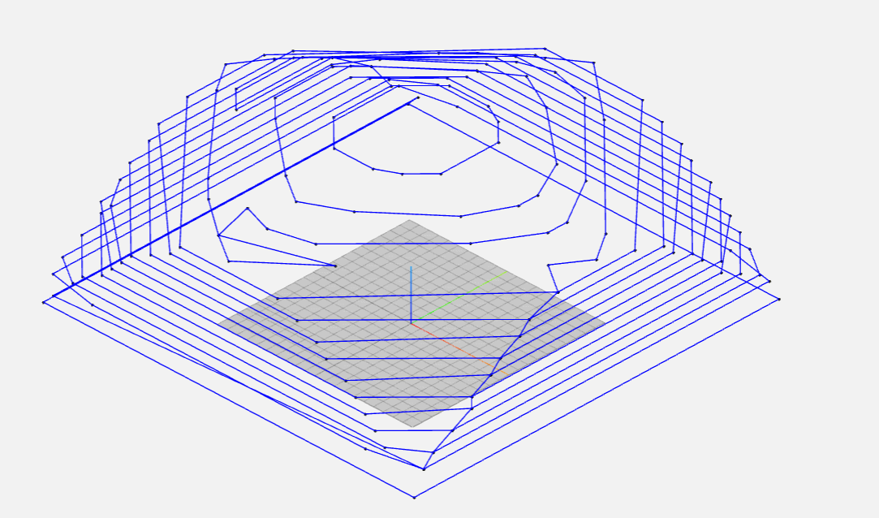
Figure 8: Example of Doubling Back

Smoothing Hull Points
To ensure a smooth machining process, this module is applied to points that are run through the convex hull function and the reverse offset module, making the transitions uniform and improving toolpath continuity. The module creates a copy of the points it is given and then computes a weighted average set by the `alpha` parameter using the current point and the average of the neighboring points. The module then verifies if the points are continuous and returns the points to the Toolpath.
By doing this, the smoothing module eliminates sharp transitions between layers in the Toolpath. Sharp transitions between layers can cause abrupt tool movements and fractures in the workpiece.
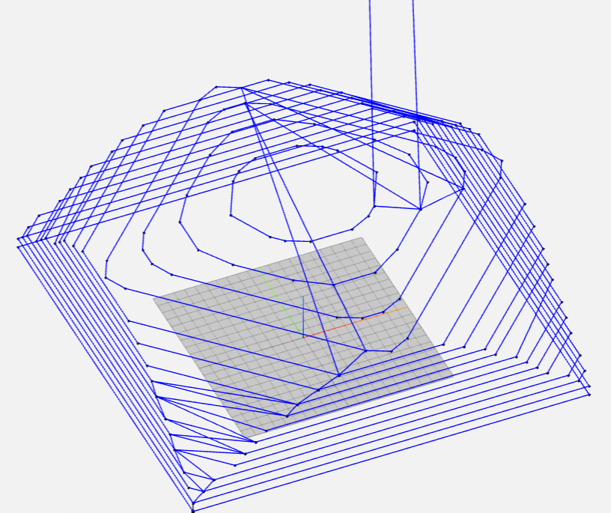
Figure 9: Example of Sharp Layer Transitions

Applying Reverse Offset
Reverse offset is a method for adjusting a machine's Toolpath to accommodate the dimensions of the machining tool, as the Toolpath is naturally generated as if the machining tool were a point. This method considers both the shape's geometry and the machining tool's dimensions to accurately determine the tool's position for the machined product, ensuring it meets the designed product's dimensions, as illustrated in Figure 10 below.
The reverse offset module, in this case, adjusts the Toolpath to account for the tool's geometry and material springback, ensuring accurate forming. During this process, the center of the tool is calculated from the points being processed in the main toolpath generation loop, defining the layer's shape. Then, the tool diameter and z_springback_offset values are applied to the points on the Toolpath to ensure that the machined shape is accurate. Finally, the adjusted 3D points are returned, incorporating the offset and smoothing.
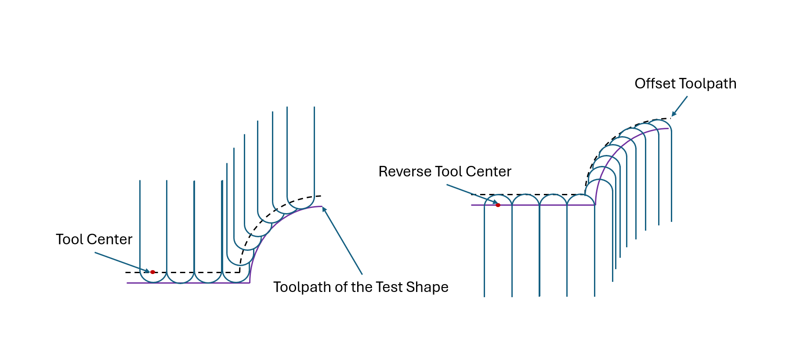
Figure 10: Reverse Offset Method

2.4 Toolpath Generation Process

Main Toolpath Generation Loop
The main loop integrates all previous functions to create a cohesive toolpath that can later be converted to G-code, as detailed in the Appendix, code A10. The loop processes the point cloud by every Z-level or layer of the STL file to create a continuous toolpath. The loop begins by creating an empty list where the Toolpath will be stored after it is generated from the coordinates.
The loop will also keep track of the last point for smooth layer transitions and closing the layer. For the first layer in the shape, the point closest to the centroid is selected as the starting point. For the subsequent layers, the point that is closest to the last point of the previous layer is chosen. The loop starts processing the layers from top to bottom, mimicking the incremental forming process [2]. The loop calculates the centroid for the layer, using 5 points, to ensure sufficient data for the convex hull computation. Next, the convexhull identifies the outermost points of the 2D layer, defining the layer for machining [3]. After convexhull is applied, all the modules previously discussed, except for the STL loading and point cloud formation, are applied to the list.
Finally, the loop stores the processed layer in the list that it created at the beginning of the process, and the last point in the list is set as the first point for the next layer.
The use of uniform Z-levels and convex hulls ensures compatibility with CNC machining. At the same time, the Toolpath points selection process starts and optimizes the tool traveling time. The optimizations to the CAM system reduce machining time and enhance efficiency [3].

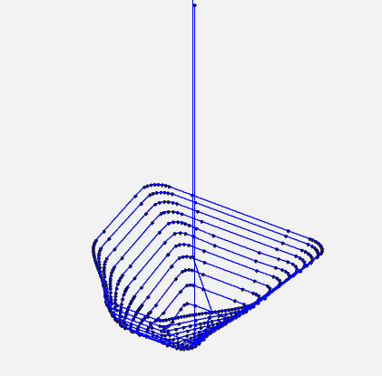
Figure 11: Toolpath Generation for Complex Shape [Wong, 2025].

2.6 G-Code Generation and Export
This final section of the code converts the coordinate points into the Toolpath by applying the G-code functions and exports it for CNC machining, as shown in Appendix, code A11. First, the Z-coordinates are adjusted by subtracting the value of the Z_OFFSET variable to align the Toolpath with the CNC machine's workspace. The values are then rounded to two decimal places to increase the precision of the Toolpath. The list of coordinates is saved as a CSV file (`toolpath.csv`) for storage. A DataFrame is created with G-code commands, prefixed coordinates (`X,` `Y,` `Z`), and semicolons (`;`) as end-of-block markers, and then combined with the coordinates to generate the Toolpath.
After this, a header and footer are added to the Toolpath with the G-code annotations ready for use in the CNC machine. The header and footer are shown in the Appendix in code A12 and code A13, respectively. The G-code conversion ensures compatibility with CNC machines, enabling automated incremental forming [9]. The header and footer streamline machine setup and shutdown, while the centroid-based initial move optimizes tool positioning, reducing setup time. The G-code conversion enables the improvement of the design-to-manufacturing process.[2]. Finally, the file is exported to a text file titled `Gchord.txt` so that a CNC input can use it.

2.7 NC Viewer Confirmation
To validate the Toolpath, the website NCviewer.com is used to visualize and simulate the forming process, identifying and addressing potential issues before the manufacturing process begins. An example of NCviewer in use is shown in Figure 11 and Appendix, Figure A1.

Chapter 3: Incremental Forming Experiment and Evaluation

3.1 Introduction
As mentioned in Section 1.5, this study aims to enhance the CAM system by building upon previous research, which is outlined in the Appendix. The main areas of focus for the CAM system are its ability to produce precise, error-free toolpaths for the incremental forming of discontinuous CFRTP with more complex geometries, the speed at which the program can output the Toolpath, and streamlining the process from design to manufacturing. To evaluate the CAM system’s ability to generate an error-free toolpath, the Toolpath generated by the CAM system will be used on nylon sheets and discontinuous CFRTP.

Experimental Equipment
Much of the equipment used in this experiment will be the same as that used in previous research (A) and is summarized in Table 3.1 below.
Table 4: Experimental Equipment Specifications
Equipment | Description | Specification
CFRTP Sheet | PA6 matrix, 20 wt% carbon fiber | 110 mm × 110 mm × 1 mm, dried at 120°C for 24 h (ETTAS oven)
Oil Bath | T-22H (Thomas Scientific) | Up to 200°C, ±0.2°C precision, jet circulation
Silicone Oil | KF968 (Shin-Etsu) | Non-volatile, stable to 250°C, fire-resistant
CNC Machine | Sodick MC430L | X 420 mm, Y 350 mm, Z 200 mm, feed up to 36 m/min
Tool (Mandrel) | SUS304 | 5 mm diameter, 2.5 mm radius tip, 60 mm length
Jig | Custom design | Submerged in an oil bath, secure clamping, detachable

Machining Center
The Sodick MC430L is a vertical precision linear machining center. The machining center can read the G-code toolpaths used in the tests. The machining center can move in three directions, X, Y, and Z, and features a tool clamp attached to the Z axis. The maximum travel distance of the machining center is 420 mm in the X direction, 350 mm in the Y direction, and 200 mm in the Z direction. The maximum feed rate or maximum speed that the machine center can move is 36 m/min, and the maximum spindle speed is 40,000 rpm.
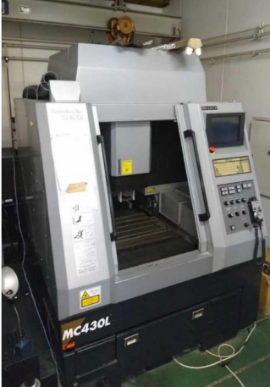
Figure 12: Appearance of MC430L

Discontinuous CFRTP
As mentioned in Section 1.3.4, discontinuous fiber CFRTP was selected as the testing material due to its cost-effectiveness, partial recyclability, and short molding time. These characteristics make it suitable for the incremental forming of complex, low-volume components in various industries, as mentioned in a previous section. The CFRTP is composed of 20% carbon fiber, with the remaining 80% being a common thermoplastic known as nylon 6. The dimensions of the individual sheets are 110 mm × 110 mm × 1 mm. It was chosen for its isotropic strength, high formability under pressure, and cost-effectiveness [12].

Oil Bath
The T-22H oil bath provides uniform heating up to 200°C with a precision of ±0.2°C, can hold up to 21 liters of liquid, and measures 425 mm x 350 mm x 150 mm. This oil bath was used in this study to process the discontinuous fiber CFRTP at the temperature that produced the best results from the previous research, which was 150 °C. The oil bath's accurate temperature control allows the temperature to be consistent during the forming process. The oil bath is secured in the machining center during the forming process to keep the CFRTP at the desired temperature.
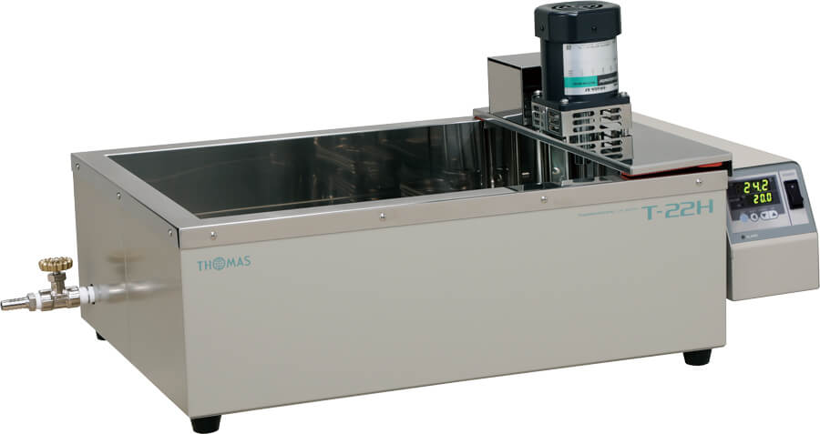
Figure 13: Appearance of T-22H [Wong, 2025]

Type of Oil
The oil used to heat the CFRTP is Shin-Etsu KF968 silicone oil due to its ability to retain high temperatures of up to 250°C. The ability of the oil to retain high temperature is important because, during the tests, the temperatures at which the tests with CFRTP are conducted are 150 °C, which is well below the 250 °C limit. Alongside its temperature resistance, low volatility, and fire resistance, these factors contribute to why the oil was selected, ensuring safety and stability at temperatures ranging from 50 °C to 200°C (323–473 K) [5].

Figure 14: Shin-Etsu Chemical KF968 oil that is used. [Tanata, 2023]

Forming tool
A SUS304 mandrel (5 mm diameter, 2.5 mm radius tip, 60 mm length) was used as the forming tip for the experiments. The mandrel was secured to the machining center by a Mega Micro Type S Chuck. The Chuck allows the forming tool to remain steady, even when rotated at high speeds, enabling incremental forming to be performed at high rotations per minute.
Table 5: Mega Micro Type S Chuck Dimensions
Mega Micro type S Chuck
Ød : | 0.45 - 6.05
ØD: | 14 mm
L: | 45
L1: | 32
G: | -
H1: | 28
H2: | 31
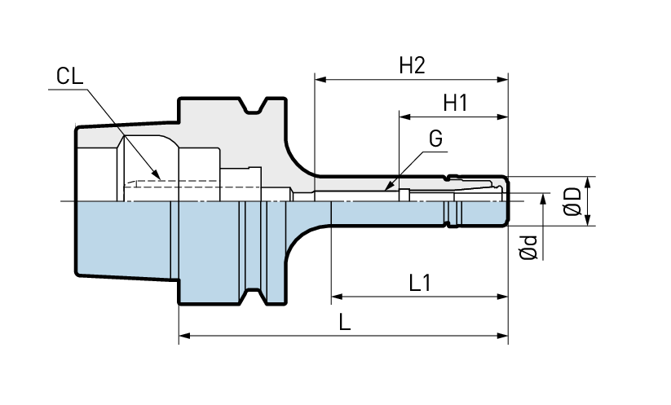
Figure 15: Mega Micro Type S Chuck Without the Tool [Big Daishowa]

Aluminum and Carbon Fiber molds
A 3D-printed mold, created using a Markforged II 3D printer, was utilized to test the feasibility of the CAM system's generated Toolpath using a nylon sheet before conducting the tests with CFRTP. The nylon sheet was chosen as it has similar properties to the CFRTP and was a less expensive material to test the Toolpath. The Aluminum mold was used for experiments with the CFRTP due to its ability to withstand the high temperatures required to bring the CFRTP into a malleable state.
Both the aluminum and carbon fiber molds are 89.92 mm x 89.92 mm x 20 mm in thickness, as shown in the technical drawing in the Figure below.
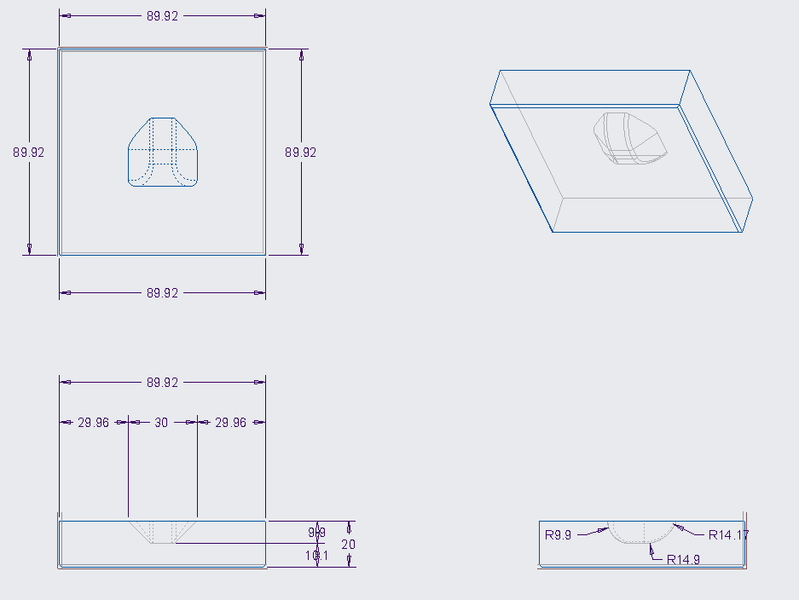
Figure 16: Technical Drawing of the Molds used in the experiment [Wong, 2025]

Jig Dimensions
A custom jig was used to secure the CFRTP in place during the incremental forming process. The Jig is 190 mm x 190 mm, with a 90 mm x 90 mm square located in the middle of the Jig. These dimensions allow for a mold to be placed in the center if needed. The Jig also has a removable upper frame that secures CFRTP sheets during the forming process. The Jig can be used with or without a mold and with or without oil, as shown in the figures below.
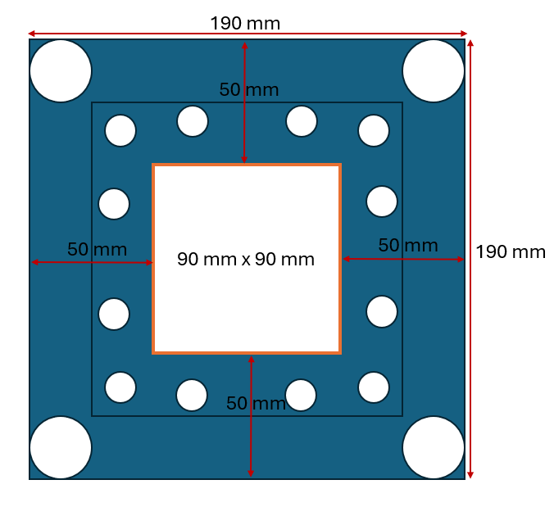
Figure 17: Jig dimensions [Wong, 2025]
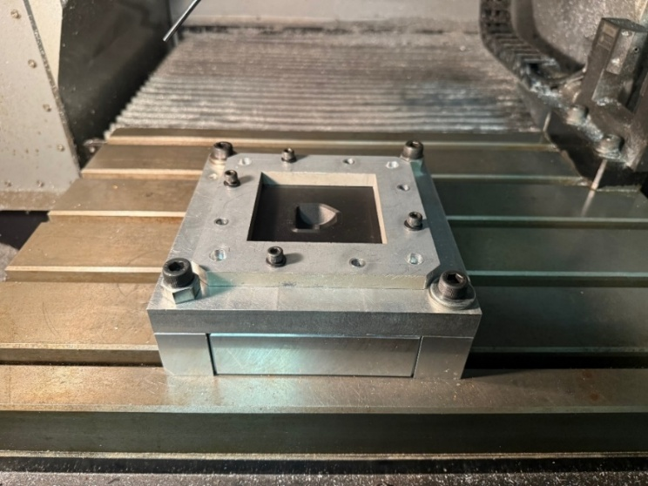
Figure 18: Jig Arrangement Outside of the Oil Bath [Wong, 2025]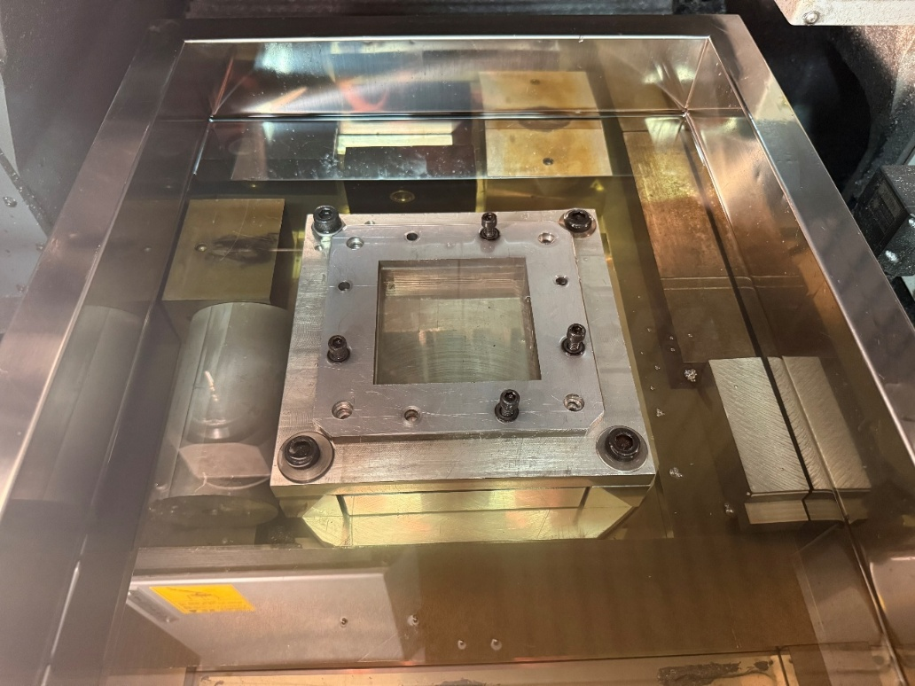
Figure 19: Jig Arrangement Inside an Oil Bath Configuration [Wong, 2025]

Test shape
To test the limits of the CAM system, the following test shape was run through the CAM system. This shape was selected as the test shape due to its greater complexity compared to the test shape used in previous research, as well as the constraints of the test materials, the physical limitations of the machining center, the machining tool, and the constraints of the type of incremental forming that is being conducted in this research. The dimensions for this test shape are 30 mm x 30 mm x 9.9 mm tall, with two chamfered sides and the other two sides rounded.
Figure 20: Test Shape Used in the Experiment [Wong, 2025]

3.3 Experimental Setup and Procedure
To test the Toolpath generated by the CAM system, the test shape was designed in Creo 9.0 parametric and exported as an STL file. The experimental equipment described in the previous section was used. The Toolpath was generated by uploading the text file to a computer that is connected to the machining center via an Ethernet cable. The Toolpath is then loaded on the machining center and used during the experiment.
The oil bath is secured to the machining center, with the Jig attached to the bottom of the oil bath, as shown in Figure 20. Depending on the testing conditions in the experiments, the mold is inserted into the Jig, and the nylon sheet or CFRTP is secured to the Jig by the upper plate. After this, the temperature is set, and two of the four tests were completed at 120°C, while the other two were completed at 150°C. After the temperature reaches the target temperature, the Toolpath can be executed to machine the test shape.
The initial setup of the machining center, prior to experimentation, is described in the Appendix, Figure A3, as it is not relevant to the overall incremental forming process used to get the results.

3.4 Experimental Results
The experimental phase of this study can be broken into two parts. The development of the CAM system, which generates precise, error-free toolpaths for complex geometries, and the testing of these toolpaths using incremental forming. The experiments were conducted using the equipment outlined in Table 4, leveraging the Sodick MC430L CNC machining center, a T-22H oil bath, and Shin-Etsu KF968 silicone oil for uniform heating. Four types were conducted, split between nylon sheets and CFRTP, with and without molds, to assess the Toolpath's performance across different conditions. The results are detailed in the tables below, with their experimental conditions and the results from the tests. There is not much data to analyze when it comes to the incremental forming experiments, as there was difficulty in analyzing the data, which will be explained in the conclusion.

CAM System Comparison
The updated CAM system demonstrated significant improvements over the previous system described in section 1.4.2. The prior system struggled to produce a toolpath for the test shapes' complex geometries, generating a toolpath with excessive points, leading to prolonged processing times and inefficient machining. For the test shape used in this study, shown in Figure 20, the previous CAM system required approximately 2 hours and 30 minutes to generate the Toolpath, as it processed redundant points and failed to optimize for the complex contours. In contrast, the updated CAM system, incorporating the new point filtering and convex hull modules, reduced the toolpath generation time to approximately 2 seconds. The time saved during the Toolpath generation process is 99%, which stems from the point filtering through the `filter_close_points` module found in Appendix Code A5, which eliminated clustering by enforcing a minimum distance of 0.5 mm between points, reducing the number of points that needed to be processed without compromising shape fidelity.
These optimizations resulted in a toolpath visualized in NCviewer.com that was not "messy" like the previous system, as you can see in Figure 21. The updated system's ability to handle complex shapes was confirmed by the successful processing of the test shape, shown in Figure ___. The test shape, as explained above, featured contours, varying wall angles, and corners compared to the simpler truncated cone used in prior research [5].
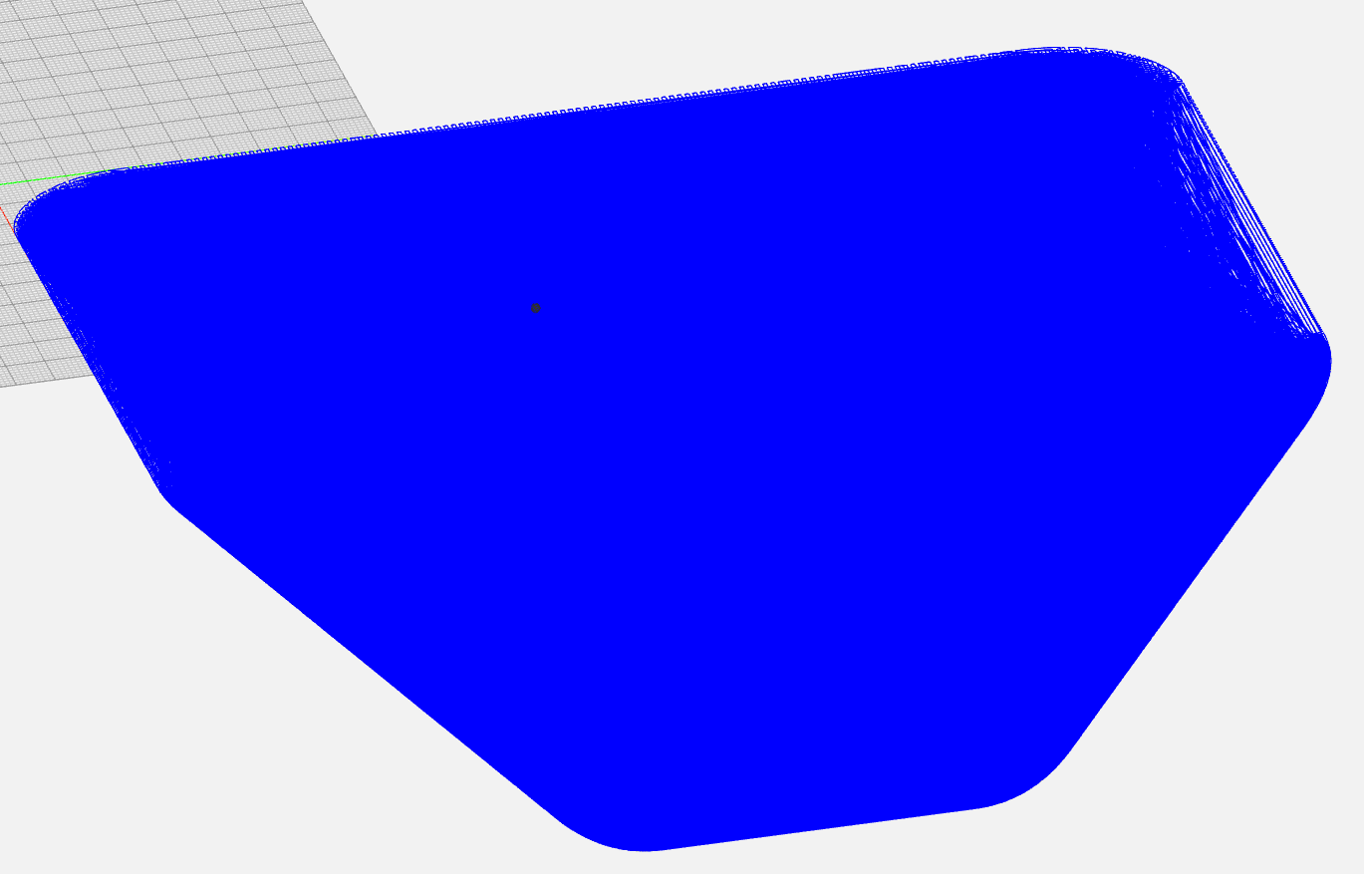
Figure 21: Toolpath from the Previous CAM system for the Current Test Shape

Incremental Forming Experiments
Four types of experiments were conducted to test the CAM-generated Toolpath, with results summarized in Tables 6–9. Due to limitations with methods to accurately analyze results from the incremental forming experiments, for the majority of the experiments, only the depth of the formed shapes was analyzed. However, visual observations on surface quality and structural integrity were noted. The experiments for forming with the CFRTP were conducted at two temperatures, 120°C and 150°C, based on optimal forming conditions identified in previous research [5], which found 150°C to yield better surface smoothness and fewer defects. Ten tests were conducted without a mold, as seen in Table 6, and 5 tests with a 3D-printed onyx mold, as seen in Table 7.

Nylon Sheet Tests
The nylon sheet tests served as a preliminary validation of the Toolpath, given nylon's similarity to CFRTP in terms of formability and lower cost. The feed rate used varies from 200 to 1000 mm/min, and the spindle speed varies from 250 to 500 rpm to assess their impact on forming depth and material thickness uniformity.
For tests without a mold, the test with the best experimental conditions was tests 9 and 10, as they had the best depth and thickness out of the experiments, as shown in Figure 22 below and Table 6. For tests with a mold, the test with the deepest depth and greatest overall thickness yielded the best results.
The tests with the mold were observed to have a much more consistent forming depth and shape versus the tests without a mold, as there was more springback from the nylon sheet.
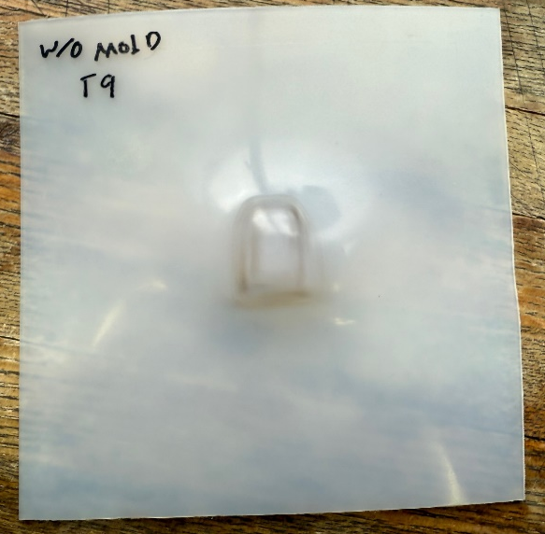
Figure 22: Image of the Test Results from Test 9 Without a Mold

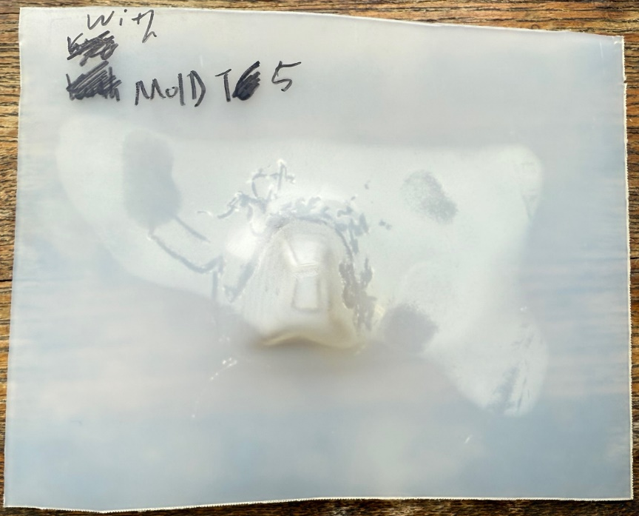
Figure 23: Image of the Test Results from Test 5 With a Mold
Table 6: Tests Without a Mold with a Nylon Sheet.
Test Number | Feed Rate (mm/min) | Spindle Speed (RPM) | Forming depth (mm)
1 | 200 | 250 | 4.79
2 | 400 | 250 | 4.64
3 | 200 | 250 | 5.59
4 | 400 | 250 | 5.89
5 | 600 | 250 | 6.41
6 | 200 | 250 | 4.02
7 | 600 | 300 | 8.3
8 | 600 | 300 | 8.33
9 | 800 | 350 | 9.72
10 | 1000 | 500 | 9.16
Table 7: Tests With a Mold with a Nylon Sheet.
Test Number | Feed Rate (mm/min) | Spindle Speed (RPM) | Forming depth (mm)
1 | 200 | 250 | 9.63
2 | 200 | 250 | 9.47
3 | 400 | 250 | 9.43
4 | 400 | 250 | 9.31
5 | 200 | 250 | 9.54

CFRTP Tests
The CFRTP tests were more challenging due to the material's higher stiffness and sensitivity to thermal conditions. Only four tests were completed due to time constraints, primarily caused by the time it took for the oil bath to cool down and for the CFRTP to reharden, taking one day to fully cool. The tests with mold used an aluminum mold for thermal stability and were conducted at 120°C and 150°C. The first two tests were conducted at 120°C and failed due to premature removal of the CFRTP from the oil bath before the cooling process was completed, leading to material deformation and cracking. The test at 150°C was successful and achieved a forming depth of 10.8 mm, with a rough surface and other defects that are negligible as shown in Figure 24.
The test at 150°C without a mold achieved a forming depth of 9.80 mm, slightly less than the mold-assisted test. The lack of mold led to a lack of depth and some visible minor defects, as seen in Figure 25 below.
The CFRTP tests highlighted the material's sensitivity to temperature and the importance of the correct machining conditions for complex shapes. The Toolpath performed reliably, but the formed shapes exhibited more visual defects than expected. More research is needed on the incremental forming process of CFRTP for complex geometries.
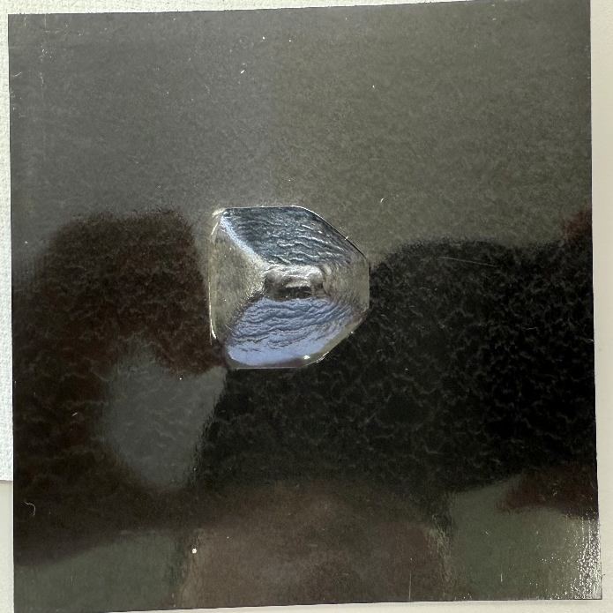
Figure 24: Image of the Test Results from Test 3 With a Mold

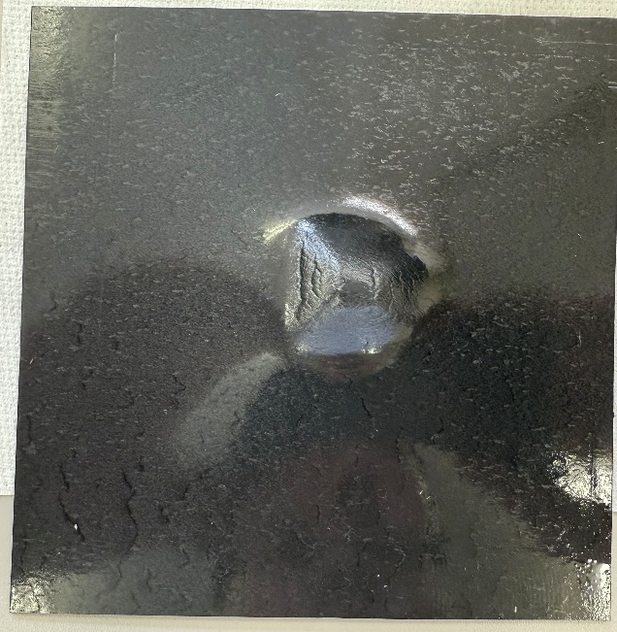
Figure 25: Image of the Test Results from Test 1 Without a Mold
Table 8: Tests with a mold with CFRTP.
Test Number | Feed Rate (mm/min) | Spindle Speed (RPM) | Temperature (Degrees C) | Forming depth (mm)
1 | 400 | 400 | 120 | 9.96
2 | 1000 | 500 | 120 | 8.75
3 | 1000 | 500 | 150 | 10.80
Table 9: Tests without a mold with CFRTP.
Test Number | Feed Rate (mm/min) | Spindle Speed (RPM) | Temperature (Degrees C) | Forming depth (mm)
1 | 1000 | 500 | 150 | 9.85

3.5 Evaluation
The updated CAM system and experimental results confirm significant advancements over the previous system, particularly in handling complex geometries, improving toolpath generation speed, and streamlining the design-to-manufacturing process. The performance and results will be broken down by section below, shedding insight into the system's strengths, limitations, and potential applications.

Toolpath Precision and Error-Free Generation

The updated CAM system successfully generated error-free toolpaths for the complex test shape, as validated through NCviewer.com simulations, as shown in Figure 11. The incorporation of advanced modules—point filtering, convex hull computation, sorting to prevent doubling back, smoothing, and reverse offset—addressed the previous system's limitations, such as redundant points and inefficient paths when dealing with complex shapes. The toolpath visualization showed smooth, continuous trajectories with no intersections or abrupt transitions, which translated to a reliable Toolpath for the machining center to use when conducting the incremental forming experiments. The system's ability to process STL files and generate G-code in about 2 seconds, compared to the previous system's two and a half hours, demonstrates the optimization done for the updated CAM system. This efficiency is critical for rapid prototyping, for which incremental forming is typically used.

Speed of Toolpath Generation
The reduction in the toolpath generation for the test shape that had complex geometry showcases the improvements from the previous CAM system. By using libraries like NumPy, Pandas, and SciPy, the system was able to handle the large point cloud that included hundreds of thousands of points and optimize them into a concise and accurate toolpath. The cluster prevention module reduced point density by enforcing the minimum distance of 0.5 mm, while the overlap prevention module minimized travel distance, reducing the computational resources needed to generate this Toolpath. The use of uniform Z-levels controlled by the LAYER_THICKNESS variable and the convexhull function further streamlined the process.

Streamlining Design-to-Manufacturing
The CAM system enhanced the design-to-manufacturing workflow by automatically adding the initial starting processes and termination sequences in G-code. This automation eliminated the need to manually add these processes before running the program, allowing the program to be run immediately after processing. Other changes, such as adjustable variables to adjust to the diameter of the tool in use, the expected springback from a specific material, and the distance between layers, allow the user to tailor a variety of scenarios, allowing the CAM system to be used for different scenarios without having code an entirely new CAM system, allowing for the CAM program to produce toolpaths for different machines with different tool diameters.

Experimental Outcomes
The nylon sheet tests validated the Toolpath's reliability before tests with CFRTP were conducted. The tests achieved forming depths close to the target geometry with minimal springback when using a mold. The CFRTP tests, despite the limited number of attempts, demonstrated the CAM system's ability to create a Toolpath that can produce complex geometries with CFRTP. The successful tests with CFRTP at 150°C produced rough surfaces and acceptable depths, highlighting the importance of optimal experimental conditions. Due to the limited number of experiments done with CFRTP, not much data was obtained regarding the optimal experimental conditions for the incremental forming of CFRTP for complex geometries. However, detailed geometric analysis was not possible due to 3D scanner limitations, which leaves room for more information that could further improve the CAM system.

Chapter 4: Conclusion and Future Improvements

Conclusion
This study successfully enhanced the Python-based CAM system for static incremental forming of discontinuous CFRTP, building on the previous research CAM system. The updated system addressed several limitations the prior CAM system had, solving three issues: generating precise, error-free toolpaths for complex geometries, significantly reducing toolpath generation time for the generation of complex geometries, and streamlining the design-to-manufacturing process. The incorporation of cluster prevention, convex hull computation, non-overlapping sorting, toolpath smoothing, and reverse offset modules enabled the system to handle intricate shapes with a high degree of accuracy, as seen in Figure 11.
The toolpath generation time was reduced from 2.5 hours to 2 seconds for the complex test shape, a critical improvement for use in rapid prototyping. The experimental results with nylon and CFRTP confirmed the Toolpath's reliability, with forming depths approaching target values and minimal defects at optimal experimental conditions. Despite challenges such as time constraints due to cooling delays and scanner limitations, the system's performance achieved the set goals at the beginning of the research, supporting sustainable manufacturing by enabling the cost-effective production of lightweight, complex components.

Future Improvements
To further enhance the CAM system and address limitations observed during the experiments for the incremental forming of complex CFRTP geometries, further research and development must be done on the CAM system and the incremental forming process used to test the CAM system. Further optimization for the CAM system, more user-friendly features, industrial scalability, decreasing the time between experiments, and improved analysis methods of the incremental forming results are areas for improvement.
The creation of a user-friendly interface would streamline the process from designing to machining. Having an interface to adjust the variables and experimental conditions easily allows new operators to learn how to use the program. Adding the ability for the CAM system to find the origin of the workpiece would speed up the setup process while also creating a more user-friendly interface and leaving the possibility of industrial scalability. Currently, setting up for an experiment requires manually setting both the machine origin and workpiece origin, which leaves room for human error and a failed machining process. It also slows down the experiment cycle as the workpiece origin and machine origin must be set every time the Jig is adjusted.
To further reduce the experiment cycle time, a method of cooling the oil bath at a controlled rate so that CFRTP will not cool too fast should be researched. The current time it takes to cool the oil from 150°C is too long, limiting the ability to conduct multiple experiments with the heated oil to just one a day.
Integrating better 3D scanners would enable precise geometric analysis, allowing future researchers to make accurate judgments on how specific systems or experimental conditions impact the incremental forming process and the formed shape. Real-time monitoring with sensors for force, temperature, or vibration could offer further insight into how to improve forming quality.
The improvements mentioned above build on the system’s strengths, including rapid and high-precision toolpath generation, CAD compatibility, and the ability to form complex geometries, which address some of the limitations of the current CAM system and experimental process. Long experimental cycle times have limited geometric analysis, and the steep learning curve for the current CAM system limits the usability of the current experimental process and CAM system. Incremental forming offers a sustainable solution for rapid prototyping and small-batch production in industries such as automotive, aerospace, and medical device manufacturing.

Appendix
Table A1: Sample of the Toolpath Data for Truncated Cone.
Coordinate Number | x | y | z
1 | 35.38074 | 16.98353 | 0
2 | -24.3741 | 8.981753 | 20.16743
3 | 13.69313 | 7.26465 | 35.19882
4 | -27.8541 | -19.5488 | 8.404538
5 | -30.4515 | 4.178701 | 0
6 | 3.737267 | -18.347 | 30.56381
7 | 11.69576 | 37.38804 | 1.108847
8 | -15.4359 | -31.4054 | 7.022253
9 | 7.207543 | -25.1519 | 0
10 | -18.2936 | -18.5911 | 19.88553
11 | 10.62484 | -32.4655 | 8.289417
12 | 2.843407 | -15.5052 | 34.86311
13 | 6.157133 | -29.6092 | 13.94509
14 | 21.27377 | 2.94206 | 26.57677
15 | -4.37845 | 20.54852 | 27.25231
16 | 2.544194 | 16.76084 | 33.12099
17 | -16.3648 | -7.26247 | 0
18 | 2.508552 | 22.63757 | 0
19 | -21.9715 | 18.83982 | 0
20 | -25.9499 | 29.48961 | 1.013605
21 | 2.603134 | -13.6337 | 0
22 | 18.75938 | 29.88954 | 0
23 | -12.8895 | -0.04869 | 39.00607
24 | -25.3572 | -8.68166 | 0
25 | -3.58629 | 27.33321 | 0
26 | 24.916 | 2.324154 | 21.41337
27 | 3.57487 | -9.04673 | 43.53424
28 | -13.7942 | -1.55114 | 0
29 | -32.3798 | 21.53292 | 1.478903
30 | -7.74691 | -30.0426 | 12.74601
31 | -10.1278 | -25.489 | 0
32 | -8.70421 | -14.0673 | 0
33 | 15.25032 | -29.5634 | 0
34 | -7.70801 | -37.0219 | 3.022466
35 | 25.47657 | -5.81376 | 19.83967
36 | 30.69521 | 6.550145 | 12.28288
37 | 15.57037 | -6.714 | 0
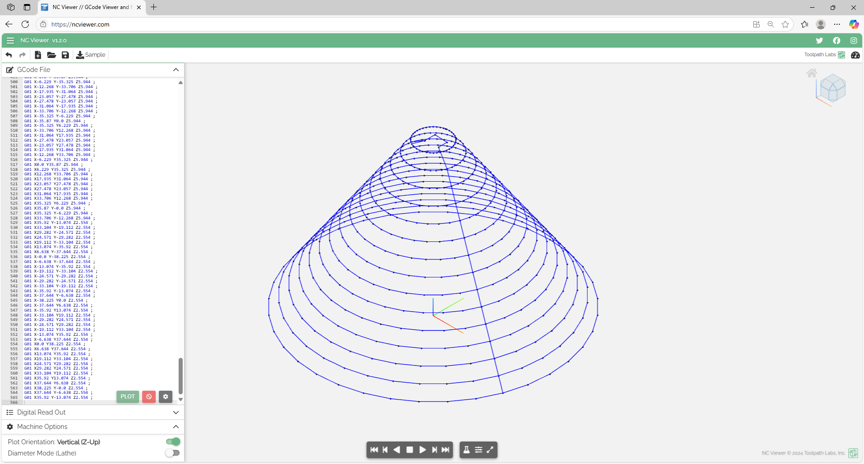
Figure A1: NC Viewer Screenshots of Toolpath Validation [Wong, 2025].

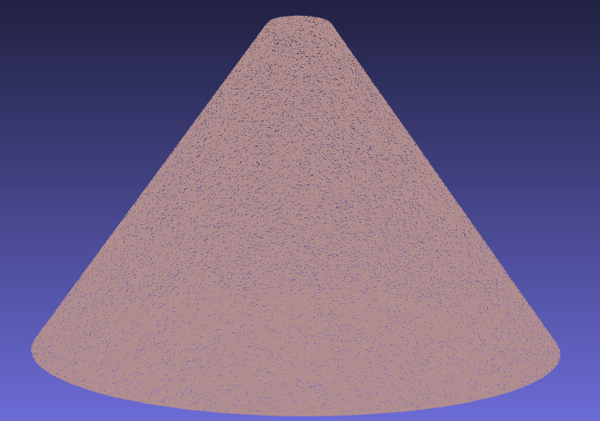
Figure A2: Point Cloud of the Truncated Cone [Wong, 2025].

import pandas as pd
import numpy as np
from scipy.spatial import ConvexHull
from stl import mesh

# Configurable parameters
TOOL_DIAMETER = 3.4 # Tool diameter (mm)
Z_SPRINGBACK_OFFSET = -0.1
LAYER_THICKNESS = 1.0
MIN_DISTANCE = 0.5
Z_OFFSET = 50.5
SAFE_Z_RELATIVE = 50.0

# Load STL file and extract points
def load_stl_to_dataframe(stl_file, layer_thickness=1.0):
stl_mesh = mesh.Mesh.from_file(stl_file)
vertices = stl_mesh.vectors.reshape(-1, 3)
df = pd.DataFrame(vertices, columns=['x', 'y', 'z'])
df = df.drop_duplicates().reset_index(drop=True)
df['z'] = np.round(df['z'] / layer_thickness) * layer_thickness
return df.dropna()

# Filter close points to prevent clustering
def filter_close_points(points, min_distance=0.5):
filtered = [points[0]]
for p in points[1:]:
if np.linalg.norm(p - filtered[-1]) >= min_distance:
filtered.append(p)
return np.array(filtered)

# Sort points to prevent doubling back
def sort_points_no_overlap(points):
center = points.mean(axis=0)
angles = np.arctan2(points[:, 1] - center[1], points[:, 0] - center[0])
sorted_indices = np.argsort(angles)
sorted_points = points[sorted_indices]
n = len(sorted_points)
for i in range(n):
p1, p2 = sorted_points[i], sorted_points[(i + 1) % n]
for j in range(i + 2, n):
p3, p4 = sorted_points[j], sorted_points[(j + 1) % n]
if intersects(p1, p2, p3, p4):
sorted_points[i + 1:j + 1] = sorted_points[i + 1:j + 1][::-1]
return sorted_points

# Check if segments intersect
def intersects(p1, p2, p3, p4):
def ccw(A, B, C):
return (C[1] - A[1]) * (B[0] - A[0]) > (B[1] - A[1]) * (C[0] - A[0])
return ccw(p1, p3, p4) != ccw(p2, p3, p4) and ccw(p1, p2, p3) != ccw(p1, p2, p4)

# Smooth hull points
def smooth_hull_points(points, alpha=0.3):
smoothed = points.copy()
for i in range(len(points)):
prev = points[(i - 1) % len(points)]
next = points[(i + 1) % len(points)]
smoothed[i] = (1 - alpha) * points[i] + alpha * (prev + next) / 2
return smoothed

# Apply reverse offset using centroid-based method
def reverse_offset(points, TOOL_DIAMETER=2.5, z_springback_offset=-0.1):
adjusted_points = points.copy()
center = points[:, :2].mean(axis=0)
distances = np.linalg.norm(points[:, :2] - center, axis=1)
layer_radius = distances.max() if distances.size > 0 else 1.0
print(f"Layer at Z={points[0, 2]:.2f}, points={len(points)}, radius={layer_radius:.2f} mm, TOOL_DIAMETER={TOOL_DIAMETER:.2f} mm")
for i, point in enumerate(adjusted_points):
direction = point[:2] - center
norm = np.linalg.norm(direction)
if norm > 1e-6:
direction /= norm
offset = TOOL_DIAMETER * direction
adjusted_points[i, :2] -= offset
print(f"Point {i}: Offset applied = {offset[0]:.2f}, {offset[1]:.2f}")
adjusted_points[i, 2] += z_springback_offset
adjusted_points[:, :2] = smooth_hull_points(adjusted_points[:, :2])
x_min, x_max = adjusted_points[:, 0].min(), adjusted_points[:, 0].max()
y_min, y_max = adjusted_points[:, 1].min(), adjusted_points[:, 1].max()
adj_distances = np.linalg.norm(adjusted_points[:, :2] - center, axis=1)
adj_layer_radius = adj_distances.max() if adj_distances.size > 0 else 1.0
print(f"Adjusted radius={adj_layer_radius:.2f} mm")
print(f"Bounding box: X=[{x_min:.2f}, {x_max:.2f}], Y=[{y_min:.2f}, {y_max:.2f}]")
return adjusted_points

# Load reference toolpath from STL file
stl_file = 'test_piece_3.stl'
df = load_stl_to_dataframe(stl_file, layer_thickness=LAYER_THICKNESS)

# Main toolpath generation loop
ll = []
prev_exit_point = None
z_levels = sorted(df['z'].unique(), reverse=True)

# Calculate the desired uniform layer spacing
if len(z_levels) > 1:
z_diffs = [z_levels[i] - z_levels[i + 1] for i in range(len(z_levels) - 1)]
avg_spacing = np.mean(z_diffs)
print(f"Average layer spacing in input data: {avg_spacing:.3f} mm")
else:
avg_spacing = 1
print("Only one Z level in input data, using default spacing of 1 mm")

# Reassign Z levels to be uniformly spaced
uniform_z_levels = []
start_z = z_levels[0]
for i in range(len(z_levels)):
new_z = start_z - i * avg_spacing
uniform_z_levels.append(new_z)

# Calculate the center of the first layer for the initial move
center_x, center_y = None, None
for layer_idx, current_layer_z in enumerate(z_levels):
current_layer = df[df['z'] == current_layer_z][['x', 'y', 'z']].values
if len(current_layer) >= 5:
center_x, center_y = current_layer[:, :2].mean(axis=0)
break
if center_x is None or center_y is None:
print("Warning: Could not compute center from any layer. Using (0, 0) as fallback.")
center_x, center_y = 0.0, 0.0

# Process each layer with the new uniform Z levels
for layer_idx, current_layer_z in enumerate(z_levels):
current_layer = df[df['z'] == current_layer_z][['x', 'y', 'z']].values
if len(current_layer) < 5:
print(f"Skipping layer at Z={current_layer_z:.2f} due to insufficient points ({len(current_layer)})")
continue

layer_points_2d = current_layer[:, :2]
try:
hull = ConvexHull(layer_points_2d)
hull_coords = layer_points_2d[hull.vertices]
except Exception as e:
print(f"Skipping layer at Z={current_layer_z:.2f} due to hull error: {str(e)})")
continue

if hull_coords.shape[0] < 5:
print(f"Skipping layer at Z={current_layer_z:.6f} due to insufficient hull vertices ({hull_coords.shape[0]})")
continue

hull_coords = filter_close_points(hull_coords, min_distance=MIN_DISTANCE)

hull_z = np.full((hull_coords.shape[0], 1), uniform_z_levels[layer_idx])
hull_points_3d = np.hstack([hull_coords, hull_z])

adjusted_points_3d = reverse_offset(hull_points_3d, TOOL_DIAMETER=TOOL_DIAMETER, z_springback_offset=Z_SPRINGBACK_OFFSET)
adjusted_points_2d = adjusted_points_3d[:, :2]

sorted_points = sort_points_no_overlap(adjusted_points_2d)

# For the first layer, start at the point closest to the centroid
if layer_idx == 0:
centroid = np.array([center_x, center_y])
dists = np.linalg.norm(sorted_points - centroid, axis=1)
start_idx = np.argmin(dists)
sorted_points = np.roll(sorted_points, -start_idx, axis=0)
elif prev_exit_point is not None:
dists = np.linalg.norm(sorted_points - prev_exit_point[:2], axis=1)
start_idx = np.argmin(dists)
sorted_points = np.roll(sorted_points, -start_idx, axis=0)

sorted_layer = np.hstack([sorted_points, np.full((sorted_points.shape[0], 1), adjusted_points_3d[0, 2])])
layer_path = list(sorted_layer)
layer_path.append(layer_path[0]) # Close the loop
ll.extend(layer_path)
prev_exit_point = layer_path[0]

if len(ll) == 0:
print("Warning: No toolpath points generated. Check input data or layer filtering.")
exit()

# Apply Z offset to drop the Toolpath
ll = np.array(ll)
ll[:, 2] -= Z_OFFSET # Subtract z_offset from all Z coordinates

# Round toolpath coordinates to 2 decimal places
ll = np.round(ll, 2)

# Save Toolpath to CSV
pd.DataFrame(ll, columns=['x', 'y', 'z']).to_csv('toolpath.csv', index=False)

# Convert to G-code
df_ltp = pd.read_csv('toolpath.csv')

# Round coordinates to 2 decimal places and format explicitly
df_ltp['x'] = df_ltp['x'].round(2)
df_ltp['y'] = df_ltp['y'].round(2)
df_ltp['z'] = df_ltp['z'].round(2)

df_gchord = pd.DataFrame({
'G': 'G01',
'x': 'X' + df_ltp['x'].map('{:.2f}'.format),
'y': 'Y' + df_ltp['y'].map('{:.2f}'.format),
'z': 'Z' + df_ltp['z'].map('{:.2f}'.format),
'EOB': ';'
})

first_x = round(df_ltp.iloc[0]['x'], 2)
first_y = round(df_ltp.iloc[0]['y'], 2)
first_z = round(df_ltp.iloc[0]['z'], 2)

# Modified G-code header to start from the centroid
gcode_header = [
"G90 ; (Absolute positioning)",
"G21 ; (Set units to millimeters)",
"M03 ; (Start spindle)",
"S500 ; (Setting spindle speed)",
"F1000 ; (Set feedrate)",
f"G00 X{center_x:.2f} Y{center_y:.2f} ; (Rapid move to centroid)",
f "G01 Z{first_z:.2f} ; (Drop to first point's Z)",
f"G01 X{first_x:.2f} Y{first_y:.2f} ; (Move to first toolpath point)"
]

last_x = round(df_ltp.iloc[-1]['x'], 2)
last_y = round(df_ltp.iloc[-1]['y'], 2)

# Final safe Z is relative to the last point's Z position
last_z = df_ltp.iloc[-1]['z']
final_safe_z = last_z + SAFE_Z_RELATIVE

gcode_footer = [
f"G01 X{last_x:.2f} Y{last_y:.2f} Z{final_safe_z:.2f} ; (Retract tool to safe Z)",
"M30 ; (End of program)"
]

with open('Gchord.txt', 'w') as f:
for line in gcode_header:
f.write(line + '\n')
df_gchord.to_csv(f, index=False, sep=" ", header=False, mode='a')
for line in gcode_footer:
f.write(line + '\n')
Code A1: Complete Python CAM System Code [Author, 2025].
%pip install pandas
%pip install scipy
%pip install numpy-stl
Code A2: Libraries required to download
import pyvista as pv
import csv
import pandas as pd
import numpy as np

# Load STL file
mesh = pv.read('test_piece_3.stl')
points = mesh.points

# Export point cloud to CSV
with open('dots.csv', 'w') as f:
writer = csv.writer(f)
writer.writerows(points)

# Process point cloud
df = pd.read_csv('dots.csv')
df = df.dropna()
df = df.set_axis(['x', 'y', 'z'], axis='columns')
maxi = df['z'].max()
mini = df['z'].min()
df = df[df['z'] > mini + 0.01]
df.to_csv('dots.csv')
df = pd.read_csv('dots.csv')
ll = np.array([0, 0, 0])
pp = np.array([0, 0, 200])

# Toolpath generation loop
while len(df) > 0:
s = df['z'].max()
df_z = df[df['z'] == s]
df_z.to_csv('layer.csv')
df_z = pd.read_csv('layer.csv')
df_z = df_z.drop(df_z.columns[[0, 1]], axis=1)
df_z.to_csv('layer.csv')
l = np.loadtxt('layer.csv', delimiter=',', dtype='float64', skiprows=1, usecols=[1, 2, 3])
n = len(df_z)
c = 0
ltp = np.array([0, 0, 0])
if n > 1:
while n > 0:
ld = [np.linalg.norm(pp - l[j]) for j in range(n)]
k = ld.index(min(ld))
lk = l[k]
ltp = np.vstack([ltp, lk])
if c == 0:
llk = lk
l = np.delete(l, k, 0)
n -= 1
pp = lk
c += 1
ltp = np.delete(ltp, 0, 0)
ll = np.vstack([ll, ltp])
df = df[df['z'] < s]
ll = np.round(ll, 3)
with open('toolpath.csv', 'w') as f:
writer = csv.writer(f)
writer.writerows(ll)

# G-code conversion
df_ltp = pd.read_csv('toolpath.csv')
df_ltp = df_ltp.set_axis(['x', 'y', 'z'], axis='columns')
l = np.loadtxt('toolpath.csv', delimiter=',', dtype='float64', skiprows=1, usecols=[1, 2, 3])
lx, ly, lz = l[:, 0], l[:, 1], l[:, 2]
lx = ['X' + str(x) for x in lx]
ly = ['Y' + str(y) for y in ly]
lz = ['Z' + str(z) for z in lz]
df_gchord = pd.DataFrame({'G': 'G01', 'x': lx, 'y': ly, 'z': lz, 'EOB': ';'})
df_gchord.to_csv('Gchord.txt', index=False, sep=" ")
Code A3: Previous research’s CAM system
def load_stl_to_dataframe(stl_file, layer_thickness=1.0):
stl_mesh = mesh.Mesh.from_file(stl_file)
vertices = stl_mesh.vectors.reshape(-1, 3)
df = pd.DataFrame(vertices, columns=['x', 'y', 'z'])
df = df.drop_duplicates().reset_index(drop=True)
df['z'] = np.round(df['z'] / layer_thickness) * layer_thickness
return df.dropna()
Code A4: Code to load an STL and create a point cloud.
def filter_close_points(points, min_distance=0.5):
filtered = [points[0]]
for p in points[1:]:
if np.linalg.norm(p - filtered[-1]) >= min_distance:
filtered.append(p)
return np.array(filtered)
Code A5: Code for Preventing Point Clustering on the Toolpath
def sort_points_no_overlap(points):
center = points.mean(axis=0)
angles = np.arctan2(points[:, 1] - center[1], points[:, 0] - center[0])
sorted_indices = np.argsort(angles)
sorted_points = points[sorted_indices]
n = len(sorted_points)
for i in range(n):
p1, p2 = sorted_points[i], sorted_points[(i + 1) % n]
for j in range(i + 2, n):
p3, p4 = sorted_points[j], sorted_points[(j + 1) % n]
if intersects(p1, p2, p3, p4):
sorted_points[i + 1:j + 1] = sorted_points[i + 1:j + 1][::-1]
return sorted_points
Code A6: The Code for Sorting Points to Prevent Doubling Back in the Toolpath
def intersects(p1, p2, p3, p4):
def ccw(A, B, C):
return (C[1] - A[1]) * (B[0] - A[0]) > (B[1] - A[1]) * (C[0] - A[0])
return ccw(p1, p3, p4) != ccw(p2, p3, p4) and ccw(p1, p2, p3) != ccw(p1, p2, p4)
Code A7: Line Segment Intersection Check
def smooth_hull_points(points, alpha=0.3):
smoothed = points.copy()
for i in range(len(points)):
prev = points[(i - 1) % len(points)]
next = points[(i + 1) % len(points)]
smoothed[i] = (1 - alpha) * points[i] + alpha * (prev + next) / 2
return smoothed
Code A8: Smoothing of the Toolpath
def reverse_offset(points, TOOL_DIAMETER=2.5, z_springback_offset=-0.1):
adjusted_points = points.copy()
center = points[:, :2].mean(axis=0)
distances = np.linalg.norm(points[:, :2] - center, axis=1)
layer_radius = distances.max() if distances.size > 0 else 1.0
print(f"Layer at Z={points[0, 2]:.2f}, points={len(points)}, radius={layer_radius:.2f} mm, TOOL_DIAMETER={TOOL_DIAMETER:.2f} mm")
for i, point in enumerate(adjusted_points):
direction = point[:2] - center
norm = np.linalg.norm(direction)
if norm > 1e-6:
direction /= norm
offset = TOOL_DIAMETER * direction
adjusted_points[i, :2] -= offset
print(f"Point {i}: Offset applied = {offset[0]:.2f}, {offset[1]:.2f}")
adjusted_points[i, 2] += z_springback_offset
adjusted_points[:, :2] = smooth_hull_points(adjusted_points[:, :2])
x_min, x_max = adjusted_points[:, 0].min(), adjusted_points[:, 0].max()
y_min, y_max = adjusted_points[:, 1].min(), adjusted_points[:, 1].max()
adj_distances = np.linalg.norm(adjusted_points[:, :2] - center, axis=1)
adj_layer_radius = adj_distances.max() if adj_distances.size > 0 else 1.0
print(f"Adjusted radius={adj_layer_radius:.2f} mm")
print(f"Bounding box: X=[{x_min:.2f}, {x_max:.2f}], Y=[{y_min:.2f}, {y_max:.2f}]")
return adjusted_points
Code A9: Reverse Offset Logic
ll = []
prev_exit_point = None
z_levels = sorted(df['z'].unique(), reverse=True)
if len(z_levels) > 1:
z_diffs = [z_levels[i] - z_levels[i + 1] for i in range(len(z_levels) - 1)]
avg_spacing = np.mean(z_diffs)
print(f"Average layer spacing in input data: {avg_spacing:.3f} mm")
else:
avg_spacing = 1
print("Only one Z level in input data, using default spacing of 1 mm")
uniform_z_levels = []
start_z = z_levels[0]
for i in range(len(z_levels)):
new_z = start_z - i * avg_spacing
uniform_z_levels.append(new_z)
center_x, center_y = None, None
for layer_idx, current_layer_z in enumerate(z_levels):
current_layer = df[df['z'] == current_layer_z][['x', 'y', 'z']].values
if len(current_layer) >= 5:
center_x, center_y = current_layer[:, :2].mean(axis=0)
break
if center_x is None or center_y is None:
print("Warning: Could not compute center from any layer. Using (0, 0) as fallback.")
center_x, center_y = 0.0, 0.0
for layer_idx, current_layer_z in enumerate(z_levels):
current_layer = df[df['z'] == current_layer_z][['x', 'y', 'z']].values
if len(current_layer) < 5:
print(f"Skipping layer at Z={current_layer_z:.2f} due to insufficient points ({len(current_layer)})")
continue
layer_points_2d = current_layer[:, :2]
try:
hull = ConvexHull(layer_points_2d)
hull_coords = layer_points_2d[hull.vertices]
except Exception as e:
print(f"Skipping layer at Z={current_layer_z:.2f} due to hull error: {str(e)})")
continue
if hull_coords.shape[0] < 5:
print(f"Skipping layer at Z={current_layer_z:.6f} due to insufficient hull vertices ({hull_coords.shape[0]})")
continue
hull_coords = filter_close_points(hull_coords, min_distance=MIN_DISTANCE)
hull_z = np.full((hull_coords.shape[0], 1), uniform_z_levels[layer_idx])
hull_points_3d = np.hstack([hull_coords, hull_z])
adjusted_points_3d = reverse_offset(hull_points_3d, TOOL_DIAMETER=TOOL_DIAMETER, z_springback_offset=Z_SPRINGBACK_OFFSET)
adjusted_points_2d = adjusted_points_3d[:, :2]
sorted_points = sort_points_no_overlap(adjusted_points_2d)
if layer_idx == 0:
centroid = np.array([center_x, center_y])
dists = np.linalg.norm(sorted_points - centroid, axis=1)
start_idx = np.argmin(dists)
sorted_points = np.roll(sorted_points, -start_idx, axis=0)
elif prev_exit_point is not None:
dists = np.linalg.norm(sorted_points - prev_exit_point[:2], axis=1)
start_idx = np.argmin(dists)
sorted_points = np.roll(sorted_points, -start_idx, axis=0)
sorted_layer = np.hstack([sorted_points, np.full((sorted_points.shape[0], 1), adjusted_points_3d[0, 2])])
layer_path = list(sorted_layer)
layer_path.append(layer_path[0]) # Close the loop
ll.extend(layer_path)
prev_exit_point = layer_path[0]
if len(ll) == 0:
print("Warning: No toolpath points generated. Check input data or layer filtering.")
exit()
Code A10: The Code for the Main Toolpath generation loop
ll = np.array(ll)
ll[:, 2] -= Z_OFFSET
ll = np.round(ll, 2)
pd.DataFrame(ll, columns=['x', 'y', 'z']).to_csv('toolpath.csv', index=False)
df_ltp = pd.read_csv('toolpath.csv')
df_ltp['x'] = df_ltp['x'].round(2)
df_ltp['y'] = df_ltp['y'].round(2)
df_ltp['z'] = df_ltp['z'].round(2)
df_gchord = pd.DataFrame({
'G': 'G01',
'x': 'X' + df_ltp['x'].map('{:.2f}'.format),
'y': 'Y' + df_ltp['y'].map('{:.2f}'.format),
'z': 'Z' + df_ltp['z'].map('{:.2f}'.format),
'EOB': ';'
})
first_x = round(df_ltp.iloc[0]['x'], 2)
first_y = round(df_ltp.iloc[0]['y'], 2)
first_z = round(df_ltp.iloc[0]['z'], 2)
gcode_header = [
"G90 ; (Absolute positioning)",
"G21 ; (Set units to millimeters)",
"M03 ; (Start spindle)",
"S500 ; (Setting spindle speed)",
"F1000 ; (Set feedrate)",
f"G00 X{center_x:.2f} Y{center_y:.2f} ; (Rapid move to centroid)",
f "G01 Z{first_z:.2f} ; (Drop to first point's Z)",
f"G01 X{first_x:.2f} Y{first_y:.2f} ; (Move to first toolpath point)"
]
last_x = round(df_ltp.iloc[-1]['x'], 2)
last_y = round(df_ltp.iloc[-1]['y'], 2)
last_z = df_ltp.iloc[-1]['z']
final_safe_z = last_z + SAFE_Z_RELATIVE
gcode_footer = [
f"G01 X{last_x:.2f} Y{last_y:.2f} Z{final_safe_z:.2f} ; (Retract tool to safe Z)",
"M30 ; (End of program)"
]
with open('Gchord.txt', 'w') as f:
for line in gcode_header:
f.write(line + '\n')
df_gchord.to_csv(f, index=False, sep=" ", header=False, mode='a')
for line in gcode_footer:
f.write(line + '\n')
Code A11: Coordinate points to G-code conversion
G90: Sets absolute positioning.
G21: Uses millimeters as units.
M03: Starts the spindle.
S500: Sets spindle speed to 500 rpm, optimized for CFRTP forming [5].
F1000: Sets feed rate to 1000 mm/min.
f"G00 X{center_x:.2f} Y{center_y:.2f} ; (Rapid move to centroid)",
f"G01 Z{first_z:.2f} ; (Drop to first point's Z)",
f"G01 X{first_x:.2f} Y{first_y:.2f} ; (Move to first toolpath point)"
Code A12: G-code Header
f"G01 X{last_x:.2f} Y{last_y:.2f} Z{final_safe_z:.2f} ; (Retract tool to safe Z)",
"M30 ; (End of program)"
Code A13: G-code Footer

Starting the machine center:
- Press the source button that is located to the left of the power button
- While the screen is turning on, turn the ‘mode’ dial to auto to ensure that the warm-up program can be run.
- If prompted, press F1 to continue the boot sequence of the machining center.
- Wait for the machine to output a large green button in the center of the screen with “power” written on it. When prompted, press the power button that is located next to the source button.
- After a few seconds, a 3 x 3 grid will appear on the screen. When the screen appears, press the ‘実行’ button. This is to set all the axes (X, Y, and Z) to their original points. The order of finding the origin is from top to bottom, and right to left is the priority of the origin setting.
- After the 3x3 grid disappears, go to ‘Files’ from the menu bar at the bottom of the screen.
- Select the ‘load’ button and start the warm-up process. The warm-up process can be found by navigating to the HDD1 folder, then scrolling down to the file named E25-sprun3M
- Do not forget to press the execute button (実行) that is in the bottom right corner of the screen.
- Then, press the ‘cycle start’ button and confirm that the spindle is spinning. The warm-up process takes about 45 minutes to an hour.
While the machine is warming up:
- Turn on the computer and select the profile that is in the middle
- The name is something like "pel2014," and the password is "pelpel."
- Double-click the "GCode" shortcut on the desktop
- Drag the code from the USB to that folder
Setting the origin for the tool:
- After the warmup process, the origin for the jig must be set. To do this, attach the ACCU-C10 High precision centering bar to the tool by switching to manual and pressing the ‘tool release’ button. The tool will fall once the button is pressed, so be prepared to catch it.
- Ensure that the spindle speed and feed rate are reset to 500 rpm and 1000 mm/min, respectively. To do so, set the mode selector switch to MDI mode and program F1000, S500, and M30 in separate lines. Run the code by pressing the ‘書込’ button and pressing the cycle start button.
- Switch the ‘mode’ selector switch to the manual, have the tool spin by pressing the sp cw button, and lower the tool near the edge of the Jig and have the tool touch the outer part of the Jig until the ACCU center is entirely in line.
- Perform step three twice for both the X and Y directions to ensure the zero is accurate. Ensure that you press the ‘zeroing button’ on the screen after every touch.
  - Ensure that an offset of 5 mm is added to the X and Y directions as the ACCU center is 5 mm in diameter, and the origin that is set in step four is off by this amount.
- After step 4 is completed, press the SP CW button to stop the tool from spinning, remove the ACCU center, and attach the machining tool to the machining center.
- Place the Base Master BM-50GH on the Jig on the workpiece and slowly lower the tool until the light turns on, and press the zeroing button. Then, raise the tool and repeat this process two more times.
- After this, move the machining center to the desired workpiece origin.
- Load the desired NC program into the machine by going to the local network, PEL _2011PC folder, scrolling to locate your file, and finally pressing the ‘実行’ button to prepare the file.
- Before running the NC program, set the feed rate override and spindle override selector switches to the lowest possible value. Feed rate override should be set to 0, and spindle override should be set to 50% before executing to ensure that the machine center does not move too fast at start-up, causing things to break.
- When steps one through nine are completed, press the "Cycle start" to start the program and slowly adjust the feed rate override and spindle override to the desired percentages.
Figure A3: Start-up procedures for the machining center.

Chapter 5: References
【1】 Bagherifard, S., Ghelichi, R., & Guagliano, M., "Shot peening: A review of the process and its applications," Journal of Materials Processing Technology, vol. 258, pp. 188–202, 2018.
【2】 Duflou, J. R., Habraken, A. M., Cao, J., Malhotra, R., Bambach, M., Adams, D., ... & Merklein, M., "Single point incremental forming: An assessment of the progress and technology trends from 2005 to 2015," Journal of Manufacturing Processes, vol. 28, no. 3, pp. 373–391, 2018.
【3】 Guttag, J. V., Introduction to computation and programming using Python, 3rd ed., The MIT Press, 2021.
[4] Tatsuki Ikari, Hidetake Tanaka, Feasibility Study of Single-Point Incremental Forming for DiscontinuousFibre CFRP using oil bath heating International Journal of Automation Technology, Vol. 18, No. 3, 433-443, 2024
[5] Hidetake Tanaka, Kippei Yamada and Tatsuki Ikari, Feasibility Study of Laser-assisted Incremental Forming for CFRTP based on 3D-CAD data, International Journal of Automation Technology, Vol. 17, No. 2, 144-155,2023
【6】 Mitsumori, T., "Development of incremental forming techniques for automotive CFRP components," Sophia University Technical Report, 2023.
【7】 Sharma, V., Sharma, V., & Shukla, O. J., Principles and practices of CAD/CAM, Katson Books, 2014.
【8】 Shovic, J. C., & Simpson, A., Python all-in-one for dummies, Wiley, 2021.
【9】 Smid, P., CNC programming techniques, Industrial Press, 2006.
【10】 Tanata, H., "Carbon-fiber-reinforced-polymer manufacturing techniques," Sophia University Technical Report, 2023.
【11】 "Radiolucent Carbon Fiber–Reinforced Pedicle Screws for Treatment of Spinal Tumors: Advantages for Radiation Planning and Follow-Up Imaging," ScienceDirect. [オンライン]. Available: https://www.sciencedirect.com/science/article/abs/pii/S1878875017305971(Last accessed on 2024/07/07)
【12】 "State of the Art in Incremental Forming," PMC. [オンライン]. Available: https://pmc.ncbi.nlm.nih.gov/articles/PMC11642863/ (Last accessed on 2024/07/07)
【13】 "Incremental Forming," ScienceDirect. [オンライン]. Available: https://www.sciencedirect.com/topics/engineering/incremental-forming (Last accessed on 2024/07/07)
【14】 "The technology of Incremental Sheet Forming—A brief review of the history," ScienceDirect. [オンライン]. Available: https://www.sciencedirect.com/science/article/abs/pii/S0924013610000555 (Last accessed on 2024/07/07)
【15】 Bachmann, J., Hidalgo, C., & Bricout, S., "Environmental analysis of innovative sustainable composites with potential use in aviation sector—A life cycle assessment review," Science China Technological Sciences, vol. 60, pp. 1301–1317, 2017.
【16】 "Product Page for 61-3235-86," Axel Global. [オンライン]. Available: https://www.axel-gl.com/en/asone/d/61-3235-86/ (Last accessed on 2024/07/07)

